

**Course Manual**

**MAR 2340: Marketing Management**

**Department of Marketing Management**

**Faculty of Management Studies and Commerce**

**University of Sri Jayewardenepura**

**Sri Lanka**

# MAR 2340: Marketing Management Course Manual

## ISBN 978-624-5703-08-1

**Copyright:** © Department of Marketing Management, Faculty of Management Studies and

Commerce, University of Sri Jayewardenepura, Sri Lanka

All rights received according to the Code of Intellectual Property Act No.36,2003 in Sri Lanka.

**Published By:**

Department of Marketing Management,

Faculty of Management Studies and Commerce,

University of Sri Jayewardenepura,

Sri Lanka

**Table of Contents**

**Course Vision ............................................................................................................................... 7**

**Course Description ....................................................................................................................... 9**

**Course Content ............................................................................................................................ 11**

C**hapter 01**

## Introduction to Marketing ......................................................................................................... 13

Chapter Overview ......................................................................................................................... 13 Learning Outcomes ....................................................................................................................... 13

1.1 What is Marketing? ................................................................................................................. 14

1.2 The Nature of Marketing ........................................................................................................ 15

1.3 Role of Marketing in Business ................................................................................................ 16

1.4 Role of Marketing as both a Business Philosophy and a Business Function .......................... 20

1.5 Types of organizations which use marketing .......................................................................... 21

1.6 The importance of Marketing in a Society ............................................................................. 22

1.7 The Importance of Marketing to You ..................................................................................... 23

1.8 What marketers can offer to satisfy customer needs/ wants and demand (Market offerings) 24

1.9 Customer Delivered Value ...................................................................................................... 25

1.10 Customer Satisfaction ........................................................................................................... 27

1.11 Building Customer Relationships ......................................................................................... 28

1.12 Marketing Management Process ........................................................................................... 31 C**hapter 02**

## Marketing Philosophies/Marketing Orientation…………….……………………………….33

Chapter Overview ......................................................................................................................... 33

Learning Outcomes ....................................................................................................................... 33

2.1 Introduction to Marketing Philosophies .................................................................................. 34

2.2 What is a Marketing Orientation? ........................................................................................... 35

2.4 The product Orientation .......................................................................................................... 37

2.5 The Selling Orientation ........................................................................................................... 38

2.6 The Marketing Orientation ..................................................................................................... 39

2.7 The Societal Marketing Orientation ........................................................................................ 42

2.8 The Holistic Marketing Concept ............................................................................................. 43

Chapter 03

## Analysing Marketing Environment........................................................................................... 47

Chapter Overview ......................................................................................................................... 47 Learning Outcomes ....................................................................................................................... 47

3.1 Introduction to Marketing Environment ................................................................................. 48

3.2 Approaches to Analyse Marketing Environment .................................................................... 50

3.3 Internal and External Environmental Analysis ....................................................................... 50

3.4 Micro and Macro Environmental Analysis ............................................................................. 51

3.4.1 The Microenvironment ........................................................................................................ 51

3.4.2 The Macroenvironment ........................................................................................................ 56

3.5 SWOT Analysis ...................................................................................................................... 64

3.6 Responding to the Marketing Environment ............................................................................ 65 Chapte**r 04**

## Managing the Marketing Information System......................................................................... 67

Chapter Overview ......................................................................................................................... 67

Learning Outcomes ....................................................................................................................... 67

4.1 Marketing Information and Customer Insights ....................................................................... 68

4.2 Marketing Information System (MIS) .................................................................................... 69

4.3 Functions of a Marketing Information System ....................................................................... 70

4.3.1. Assessing Marketing Information Needs ............................................................................ 70

4.3.2 Developing Marketing Information ..................................................................................... 71

4.3.3 Analysing and Using Marketing Information ...................................................................... 77

Chapter 05

## The Buyer Behaviour and Buying Process ............................................................................... 79

Chapter Overview ......................................................................................................................... 79 Learning Outcomes ....................................................................................................................... 79

5.1. Introduction ........................................................................................................................ 80

5.2. Buyer’s Characteristics ...................................................................................................... 83

5.3. Buyer Decision Process ..................................................................................................... 88

5.4. Level of Involvement and purchase decisions ................................................................... 90

5.5. Types of Buying Behavior ................................................................................................. 91

5.6. Buying Roles ...................................................................................................................... 91 Chapter 06

## Customer Driven Marketing Strategy: Segmenting, Targeting and Positioning ................. 93

Chapter Overview ......................................................................................................................... 93

Learning Outcomes ....................................................................................................................... 93

6.1 Market Segmentation .............................................................................................................. 94

6.1.1 Bases and Variables for Market segmentation ..................................................................... 96

6.1.2 Requirements for Effective Segmentation ......................................................................... 103

6.2 Market Targeting .................................................................................................................. 104

1. 2.1: Market Targeting Strategies/ Levels of Market Targeting ............................................... 106
   1. Positioning the Marketing Offer ........................................................................................... 108

6.3.1.Identifying possible differences/competitive advantages .................................................. 109

* + 1. Choosing Right Competitive Advantages .......................................................................... 112
    2. Communication and Delivering the Chosen Difference/s ................................................ 113
    3. Positioning Statement ........................................................................................................ 114
    4. Positioning Maps .............................................................................................................. 114
    5. Developing a Positioning Statement ................................................................................. 114

Chapter 07

## Products, Services and Brands: Building Customer Value .................................................. 117

Chapter Overview ....................................................................................................................... 117 Learning Outcomes ..................................................................................................................... 117

7.1 Introduction ........................................................................................................................... 118

7.2. What is a Product? ............................................................................................................... 118

7.3. Product Levels: .................................................................................................................... 119

7.4. Product Classification .......................................................................................................... 121

7.5. Product Mix Decisions ........................................................................................................ 123

7.6. Product-Line Decisions ........................................................................................................ 124

7.7. Branding ............................................................................................................................... 126

7.8. Branding Decisions ............................................................................................................. 128

7.9. Packaging and Labelling ..................................................................................................... 133

Chapter 08

## Pricing: Understanding and Capturing Customer Value ..................................................... 135

Chapter Overview ....................................................................................................................... 135 Learning Outcomes ..................................................................................................................... 135

8.1. What is Pricing? ............................................................................................................... 136

8.2. Internal and External Considerations Affecting Price Decisions .................................... 137

8.3. Pricing process ................................................................................................................. 140

8.4. Major Pricing Strategies .................................................................................................. 146

8.5. New-Product Pricing Strategies ....................................................................................... 149

8.6. Price Adjustment Strategies ............................................................................................. 150

Chapter 09

## Marketing Channels: Delivering Customer Value ................................................................ 155

Chapter Overview ....................................................................................................................... 155 Learning Outcomes ..................................................................................................................... 155

9.1 Supply Chains and the Value Delivery Network .................................................................. 156

9.2 The Nature and Importance of Marketing Channels ............................................................. 157

9.2.1 How Channel Members Add Value ................................................................................... 158

9.2.2 Number of Channel Levels and Flows ............................................................................... 161

9.3 Channel Behaviour and Organization ................................................................................... 164

9.4 Channel Design Decisions .................................................................................................... 168

9.5 Channel Management Decisions ........................................................................................... 169

Chapter 10

## Communicating Customer Value: IMC Strategy .................................................................. 171

Chapter Overview ....................................................................................................................... 171 Learning Outcomes .................................................................................................................... 171

10.1 Communication ................................................................................................................... 172

10.2 Marketing Communication ................................................................................................. 172

10.3 The Role of Marketing Communication ............................................................................. 173

10.4 Communication Process ...................................................................................................... 173

10.5 Integrated Marketing Communication (IMC) ..................................................................... 177

10.7 Elements that Contributes to Effective Marketing Communication (Marketing

Communication Mix) .................................................................................................................. 184

# Course Vision

“Marketing today is not a function; It is a way of doing business” – Begis McKenna (1991, p.69)

Marketing function of an organization takes the primary responsibility to create and maintain a viable fit between the marketplace opportunities and the firm. Modern day organizations are keen to have a marketing orientation to all their operations as customer satisfaction leads to competitive advantages that ensure higher value creation. This approach is of vital importance to understand that ‘Customers’ are the central point of decision making of any business. In addition, Marketing needs to be viewed as the integrating function that links the customers and the business.

Marketing puts more emphasis on customers and the identification of customer requirements. Therefore, to sustain and excel, every firm must work hard to retain its existing customers and continuously give attention to securing new, profitable customers.

Marketing was originally found as ‘a branch of applied economics’ devoted to the study of distribution channels. Later, it became a ‘management function’ devoted to managing the sales function of organizations. In modern times, marketing is viewed as ‘an applied behavioural science’ that is concerned with understanding buyer and seller psychological encounters.

Currently, following the global trends, even in Sri Lanka, there seems to be a growing awareness about applying marketing concept in non-profits (not for profits) organisations too. However, even in some private sector profit oriented organizations, though they claim about customer care through the media, less evidence of customers orientation is found in their actual dealings with the customers. Hence, we still see an immense opportunity to develop marketing applications in Sri Lankan organisations. As graduates of business management (some of you as future marketers), you are expected to view the whole business operation from its end result - *the customer*. We firmly believe that this introductory course in marketing will provide you with a sound theoretical basis with a practical flavour of how marking is practiced in the real world. We wish everyone of you to receive an intellectually challenging, thought provoking and pleasant learning experience with MAR 2340: Marketing Management subject offered by the Department of Marketing Management.

Teaching Team- MAR 2340: Marketing Management Department of Marketing ManagementUniversity of Sri Jayewardenepura.

# Course Description

MAR 2340: Marketing Management course provides undergraduates with a basic and intermediary level of knowledge and understanding about the nature and the scope of Marketing Management using practical applications in both the Sri Lankan and Global contexts. It focuses on discussing key marketing concepts, theories, principles, and applications in the area of marketing management. Further, the course provides an understanding on trends and new developments in the area of marketing. Thus, after successfully completing the course, students should be able to understand key marketing functions within organizations, identify problems faced by them and suggest relevant marketing strategies

# Intended Learning Outcomes (ILO)

After successfully completing this course, students should be able to:

ILO 1 Define Marketing, Marketing Management and marketing concepts

ILO 2 Describe Marketing Process

ILO 3 Recognize the role and importance of marketing in the present business context

ILO 4 Identify key marketing environments, their influences and new trends.

ILO 5 Discuss the influence of key stakeholders to the marketing functions

ILO 6 Explain marketing strategies and tactics.

ILO 7 Use the knowledge of marketing strategies to make appropriate recommendations for entities.

ILO 8 Assess the ethical aspects in marketing

ILO 9 Demonstrate communication, negotiation, analytical, teamwork, leadership skills and creativity

**Manual prepared by:**

Professor Lalith Chandralal

Associate Professor Asoka Malkanthie

Dr. Dushan Jayawickrama

Dr. (Mrs) Sandamali Galdolage

Mr. Harsha Tissera

Mr. Aminda Lakmal

Mrs Pavani Lakshika

**Edited By:**

Senior Professor Neville Warnakulasooriya

Professor Rohini Samarasinghe

Professor Amila Jayarathna

Professor Lalith Chandralal

Associate Professor Asoka Malkanthie

Dr. Dushan Jayawickrama

Dr. (Mrs) Sandamali Galdolage

# Course Content

|  |  |
| --- | --- |
| **Chapter No.** | **Topic** |
| Chapter 1 | Introduction to Marketing |
| Chapter 2 | Marketing Management Orientations |
| Chapter 3 | Analysing the Marketing Environment |
| Chapter 4 | Managing Marketing Information to Gain Customer Insights |
| Chapter 5 | Consumer Markets and Consumer Buyer Behaviour |
| Chapter 6 | Customer-Driven Marketing Strategy: Creating Value for Target Customers |
| Chapter 7 | Products, Services and Brands: Building Customer Value |
| Chapter 8 | Pricing: Understanding and Capturing Customer Value |
| Chapter 9 | Marketing Channels: Delivering Customer Value |
| Chapter 10 | Communication Customer Value: Integrated Marketing Communications Strategy |



**Introduction to Marketing**

# Chapter Overview

The chapter one focuses on giving an understanding on what the marketing is including its nature and scope~~;~~ role as a function and a philosophy~~;~~ importance to different parties such as organisations, individuals, and society. The chapter further explains what marketers can offer

(market offerings) to achieve its ultimate goal while describing the terms ‘Customer Perceived

Value’ and ‘Customer Satisfaction’. Finally, the chapter discusses the importance of ‘Relationship Marketing’ while illustrating different customer groups based on their loyalty and profitability and ends with explaining the marketing management process.

# Learning Outcomes

At the end of this chapter you should be able to,

* Define marketing
* Explain the role of marketing in business and society
* Distinguish different types of market offerings
* Recognize the components of Customer Delivered Value
* Define the term ‘Customer Satisfaction’ and its importance
* Identify the importance of Customer Relationship Marketing and different types of relationship groups.
* List down the steps in the marketing management process



*Marketing is the process by which companies create value for customers and build strong customers relationships in order to capture value from customers in return.*

*(Kotler & Armstrong, 2016)*

**1.1 What is Marketing?**

Marketing is understood differently by different people. Some people narrowly define marketing as all the activities taking place between production and consumption. Others think marketing as just selling and advertising. These represent the tip of the ice burg of which the hidden part represents the most important area of marketing which is called “homework”. This part includes analysing marketing opportunities, identifying proper customers, designing appropriate products, pricing correctly, distributing and communicating effectively etc. Therefore, modern marketers show that marketing begins before the production and continues even after the consumption. If a company carries out this homework soundly, it makes selling and advertising unnecessary.

*Selling & Advertising is like the Tip of the*  *marketing iceberg which is visible to everybody*

*The aim of marketing is to make selling unnecessary*

*(Peter Drucker)*

Another simple yet better definition of marketing is that “Meeting needs profitably”. This draws the marketers’ attention to customers’ need and emphasise the exchange between customers and marketers.

Considering the role of marketing in both business and society, Kotler (2016) defines marketing in a broad perspective as follows.

*“Marketing is a social and managerial process by which individuals and organizations obtain what they need and want through creating and exchanging value with others”*

This definition covers both micro marketing (as a managerial process) and macro marketing (as a social process). It highlights the concepts; needs, wants, products, value and exchange. From this managerial and social process people as individuals and as groups (e.g. families, firms) fulfil their needs and wants.

## 1.2 The Nature of Marketing

Marketing is a discipline which has a direct impact on individuals, households, organizations and the whole societies nowadays. It is commonly believed that marketing is omnibuses. It is explained as a philosophy, art, science and a way of living of people. Every minute, we are influenced by marketing. Around fifty percent of a rupee we pay for a product is spent on marketing associated with that product. The level of consumption that we maintain is directly determined by marketing function of the society.

## 1.3 Role of Marketing in Business

Marketing plays a vital role behind the survival and growth of business organizations. It directly deals with the customer markets to bring prosperity to business organizations. It bears the responsibility to obtained and manage appropriate level of demand for the products and services of businesses.

Marketing is treated as both an overall business philosophy and an important functional area of management, which recognizes that the identification, satisfaction and retention of customers are the key to prosperity. This is particularly important, as much of the problem of definition and misunderstanding over the term ‘marketing’ stems from the confusion between the function of marketing and its philosophy. The term ‘marketing’ is used to describe both the techniques used by the marketing department and the overall marketing orientation of the firm. Thus, Marketing is in fact both a function and a business philosophy.

### 1.3.1 Marketing as a Functional Area of Management

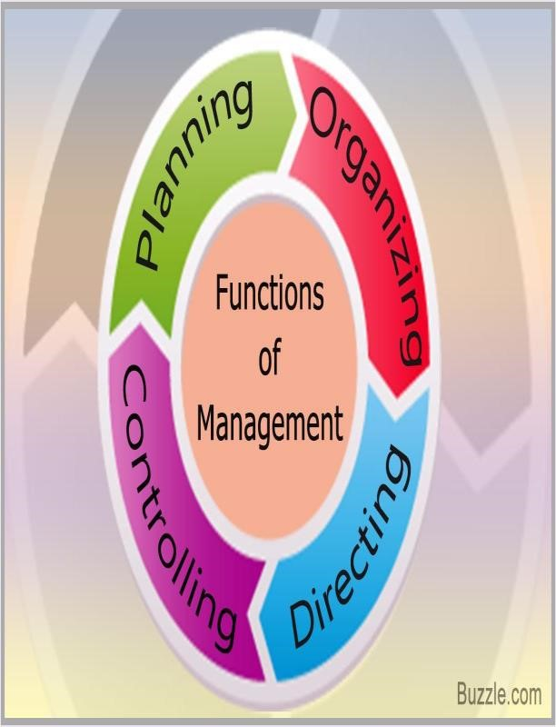One of the perspectives in understanding of marketing is taking marketing as a managerial function called ‘marketing management’, similar to the other functions of the business organisation such as human resources management, financial management, operational management etc. Generally, a separate department is established in organisations to execute this marketing function called the ‘department of marketing management’.

Thus, many organisations have a marketing department made up of marketing generalists, e.g. the marketing manager, the purchasing manager, the sales manager, marketing research manager and so forth. Such a marketing department is obviously based in a physical location within the organisation and involved with handling marketing techniques and strategies. These techniques cover such areas as purchasing, sales, production, pricing, distributing, advertising and promotion, marketing research, planning and after sales services. Many of these functions of marketing offer separate career opportunities and are often undertaken by specialists, with the marketing manager who is responsible for coordinating all the separate but interrelated activities.

As a function, one of the important roles of marketing is to correctly identify both current and future needs and wants of specifically defined target markets and managing the marketing tasks to satisfy such needs and wants profitably. In fact, basically the process of marketing management is not different from any other functional area of management and essentially comprises of the following key tasks.

**Analysis:** The starting point of marketing management decisions is analysis. Customers, competitors, trends and changes in the environment, and internal strengths and weaknesses must each be fully understood by the marketer before effective marketing plans can be established. Analysis, in turn, requires information using systematic marketing research and marketing information systems.

**Planning:** The second task of marketing manager is the planning process. The marketing manager must plan both long-term marketing directions for the organisation (strategic planning), including the selection of target markets, and the marketing programmes & tactics that will be used to support these strategic plans.

**Implementation:** Both strategic and tactical plans must of course be acted upon if they are to have any effect. The implementation tasks of marketing management involve such activities as staffing, allocating tasks and responsibilities, budgeting and securing any financial and other resources needed to translate plans into action.

**Control:** The final task of marketing manager is measuring and evaluating progress against objectives and targets established the plans.

Although marketing is a very important functional role within the organisation, the influence of marketing should not be restricted to the marketing department. A marketing –oriented business has implications for the way people throughout the organisation respond to the initiatives that as an overall business philosophy.

### 1.3.2 Marketing as an Overall Business Philosophy

Many firms do not see marketing as another functional area of management but more as an overall business philosophy, a way of thinking about business and a way of working which runs through every aspect of the firm’s activities. Therefore, many successful companies see marketing as the keystone of their business. They are not viewed it as a separate function, but rather as a profit – oriented approach to business that permeates not just the marketing department but the ***entire business***. From this point of view, marketing is seen as an attitude of mind or an approach to business rather than a specific discipline. It highlights the customer centred thinking throughout the organization and a sound inter-functional support and coordination. It further emphasises that business managers should look through a window rather than a mirror. i.e. should focus on effectiveness rather than efficiency!

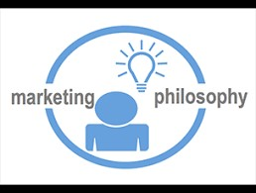 *“Marketing is not only much broader than selling, it is not a specialized activity at all. It encompasses the entire business. It cannot be considered a separate function. It is the whole business seen from the point of view of its final result, that is, from the customer’s point of view. Concern and responsibility for marketing must therefore permeate all areas of the enterprise”*

*(Peter F. Drucker)*

Therefore, marketing cannot begin to be effective within a firm unless it has the firm support of all managers and employees in every area of an organization.

## 1.4 Role of Marketing as both a Business Philosophy and a Business Function

Marketing as a **business philosophy** is concerned with the achievement of **effectiveness** - the ability to achieve appropriate objectives (“doing the right thing”). In other words, it reflects the ability to create and keep a profitable customer. It brings right products, right markets, and right strategies to the minds of marketers. It highlights outside-in thinking rather than inside-out thinking. Therefore, it directly affects the growth of the business.

|  |  |  |
| --- | --- | --- |
| Functional management is concerned with the management of the marketing | **Figure 1.1: Principle combination Effectiveness and Efficiency** | **of** |

functions including product, price, place, and promotion activities. Thus, marketing functions are dedicated to efficiency(“doing things right”). Efficiency means the ability to minimize the use of resources in achieving organizational objectives (input-output ratio). Figure 1 summarizes the principle combinations of effectiveness and efficiency.

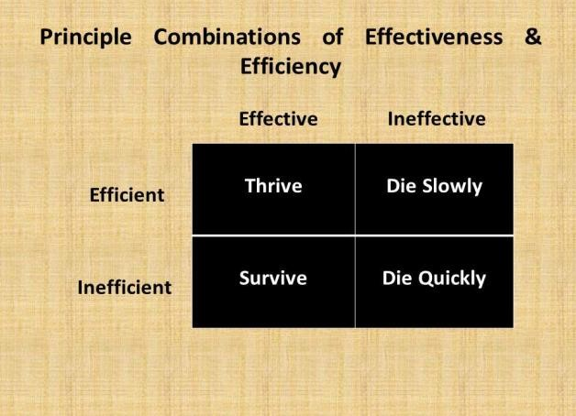

Business organizations, which are operationally efficient and strategically effective, will thrive, but even a relatively inefficient organization will at least survive if it can create and keep customers. Companies which are ineffective, which are unable to adopt as their market changes, are designed to die, increasing efficiency ultimately delay this. “In business, the followers are customers. To produce these customers, the entire organization must be viewed as a customer – creating, and a customer – satisfying organism. Management must think of itself not as producing products but as providing customer- creating value satisfaction”. Marketing as a philosophy should be embraced by entire organization.

*Carefully look at few organisations operating in Sri Lanka. Considering their level of efficiency and effectiveness, try to identify them under ‘thrive’, ‘die slowly’, ‘die quickly’ and ‘survive’ categories.*



1.1

## 1.5 Types of organizations which use marketing

It is a common view that marketing is very much essential for business organizations, at presents all most all type of organizations is viable to adopt marketing. Companies like Hemas, Tobacco, and Unilever which are selling physical products are heavily using marketing in their business. The service providing companies are also increasingly adopting marketing to sell their services. No matter the scale i.e. large, medium, or small, any business needs to apply marketing strategies for survival and improvements. However, marketing is not only for profit-oriented business organisations. Not for profit organisations also use marketing to achieve their objectives such as communicating with their target customers, build awareness of an issue and gain financial support from the public fir its cause etc.

Therefore, marketing is for,

For-profit organizations

Not-for-profit organizations

NGOs

Government organizations

Universities, Schools, Hospitals

Associations, Societies, Religious institutions

*Application of marketing in profit-oriented business organisations are noticeable. However, why, and how notfor profit-oriented organisations use marketing is not well revealed. Identify Five (05) not -for- profit organisations*



1.2

*and recognise how and why do they use marketing with*

*appropriate reasoning.*

## 1.6 The importance of Marketing in a Society

It is generally accepted that the standard of living of people of any society is determined by the level and quality of marketing activities carried out by various parties within a society. Individuals and households are fulfilling their needs and want through the marketing function taking place within the society. Unless such a marketing function, it would not have been able to match the heterogeneous supply of the production sector with the heterogeneous demand of the households of any economy.

There are a number of discrepancies and gaps between this heterogeneous supply and demand which is illustrated by the following diagram. Unless these discrepancies and gaps are eliminated, we cannot expect a continuous and smooth flow of products moving from the production sector to household sector. If so, the level and quality of products consumed by the household sector is shrinking and thus reducing their level of standard of living. However, any society or economy has a macro marketing system comprising manufacturers, suppliers and various intermediaries who perform various marketing activities such as manufacturing, pricing, distributing, promoting, selling etc which are called universal marketing functions. By performing these functions, macro marketing system can eliminate such discrepancies and gaps between producers and consumers and continue a flow of need satisfying goods and services. Thus, if any society has a poor macro marketing system, it leads to a low standard of living among people of that particular society.

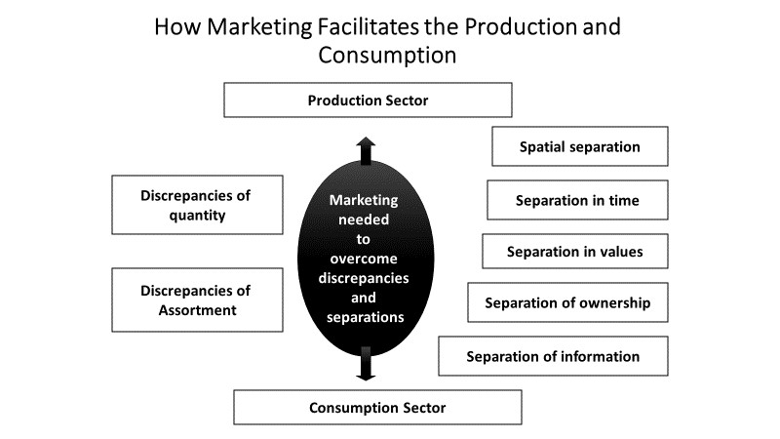 On the other hand, by eliminating such gaps and discrepancies, marketing functions provide a several type of utilities in addition to form utility provided by manufacturing.

For instances, by eliminating special gap, marketing delivers a place utility to consumers. A time utility is created and delivered by marketing by eliminating time discrepancies between producers and consumers.

Buying and selling activities provide title utility by overcoming title gap. Whole selling and retailing try to eliminate discrepancies of quantity and assortment between sellers and households.

This implies that production itself is not sufficient to meet households’ needs and wants. It must be supported by marketing functions in order to deliver a bundle of benefits (utilities) to consumers (households)

## 1.7 The Importance of Marketing to You

Marketing has an impact on you by several ways. Firstly, it directs a flow of products and services toward you for acquisition and consumption which determine your standard of living. A greater deal of products we consume is a result of marketing taking place in every moment in the world. Secondly, around 50 percent of each rupee you pay for a product is spent on marketing associated with it. It is essentials to pay such an amount on marketing as it delivers time, place, title and information utilities to you. Finally, marketing offers you a wide variety of employment opportunities in the fields such as advertising, selling, product management, branding, marketing research etc.

## 1.8 What marketers can offer to satisfy customer needs/ wants and demand (Market offerings)

Consumer needs and wants are fulfilled through market offerings. The marketer must try to understand the target market’s needs, wants and demands. ***Needs are the basic human requirements***. People need food, air, water, clothing and shelter to survive. People also have strong needs for education, recreation, and other services. These needs are not created by society or by marketers. They exist in the very texture of human biology and the human condition.

These needs become wants when they are directed to specific objects that might satisfy the given need. A Sri Lankan need food but wants a rice and curry, noodles etc. Although people’s needs are few, their wants are many. Wants of a particular society are shaped and reshaped by the culture of that society.

Wants include only willingness to buy the product/s. For a want to become a demand, it should be backed by ability to buy the product (purchasing power of the customer). Marketing management is primarily dealing with demand. The ultimate responsibility of Marketing

Management is to obtain a desired demand level from the market to the products of the company

**Product or Market Offering:**

Product is anything that can satisfy a need or want. It may be,

|  |  |
| --- | --- |
| Physical products | - Eg: Car, T.V., Radio |
| Services | - Eg: Transportation service |
| Persons | - Eg: Malini Fonseka |
| Places | - Eg: Kataragama |
| Activities/events | - Eg: Physical exercise |
| Organization | - Eg: Fitness centre / Health club |
| Properties | -Eg : Lands, Buildings, Shares |
| Information | -Eg : Research, Educational Materials |
| Experiences | -Eg. OBT programs, Rock climbing, Surfing |

## 1.9 Customer Delivered Value

### Value, Cost and Benefits

Customer value of a product is the product’s perceived ability to satisfy the customer’s need or need set. A total Customer value is the “bundle of benefits” Customers expect from a given product or service. Customers compare value of alternative products with costs of obtaining and purchasing these alternatives. Total customer cost is the “bundle of costs” that customers expect to incur from a given product or service.

Net customer value (Customer Delivered Value) is the difference between the total customer benefits that the consumer gains from owning and using a product and total customer cost of obtaining the product. This is illustrated in the following diagram.

### Figure 1.2 Determinants of Customer Delivered Value

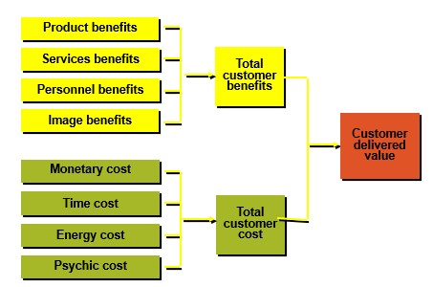

Basically, marketing argues that the central point of any organization is its customer. Given this context, the organization as a social entity looks forward to serving their customers well so that other objectives of the organizations are met.

**Customer Net Value = TCV - TCC**

Actual value is the value that the consumer places upon the good or the service after consuming it. It is the actual experience of satisfaction or dissatisfaction. Perceived value refers to the value that the consumers perceive before the actual consumption. It is the psychological expectation. This perception of value is affected by the aesthetic and unique appearance of the product, type of distribution channels, promotions, as well as the price of the product.

*Select an organisation that you have recently visited to purchase product/ or a service. Recognise what they have done to provide more benefits to you. Which type of costs (sacrifices) involved with your purchase decision?*



1.3

*How would you evaluate your perceived Value?*

## 1.10 Customer Satisfaction

Customer satisfaction occurs when a product’s perceived performance matches a buyer’s expectations.

* If the product performance fails to meet customer expectation the buyer is dissatisfied.

* If the product performance matches the buyer expectation, the buyer is satisfied

* If the product performance exceeds the buyer expectation, the buyer is delighted

### Tracking and Measuring customer satisfaction

For customer centred companies, customer satisfaction is both a goal and marketing tool. Companies use the following four methods to measure how much customer satisfaction they are creating.

* **Complaints and Suggestion Systems:** Provide forms for customer to report their likes and dislikes about the product, service, Company etc.
  + Keep suggestion boxes in front of the company.
  + Supply comment cards to customers.
  + Establish customer hotlines with free phone numbers by which customer can inquire,
  + make suggestions or complaints.

* **Customer Satisfaction Survey:** Company can obtain a direct measure of customer satisfaction by conducting periodic surveys. They can send questionnaires or make telephone or personal interviews to a random sample of their potential customers to find out how they feel about various aspects of the company’s product/service and its performance.

* **Ghost Shopping:** A company can hire persons to pose as potential buyers to report their findings on strong and weak points they experienced in buying the company’s and competitor’s products.

* 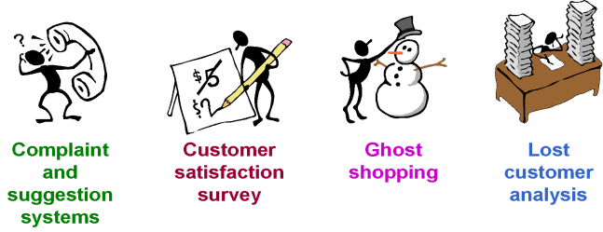**Lost Customer Analysis:**

Companies can contact customers who have stopped buying or who have switched to another supplier to learn why this happened.

## 1.11 Building Customer Relationships

Now we can understand that successful marketers try to build up long – term trusting “win – win” relationships with valued customers. Kotler defines (2000) “relationship marketing as the process of creating, maintaining and enhancing strong value – based relationships with customers and other stakeholders”. This is accomplished by promising and delivering high quality goods and services and fair prices to the customers overtime. It is also accomplished by building strong economic, technical and other social ties with other parties – distributors, dealers, suppliers etc.

Therefore, the task of creating strong customer loyalty is called ‘relationship marketing’ The relationship marketing explains four different levels of relations to customers.

Four groups of customers have been recognised based on their profitability and projected loyalty.

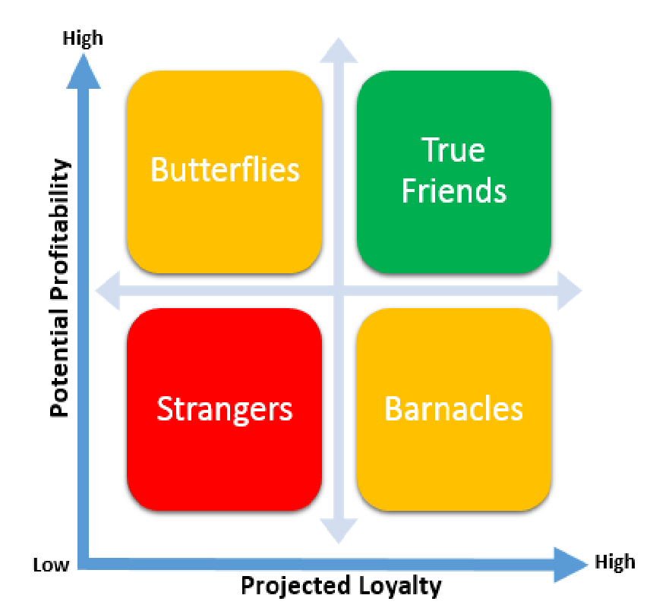**Butterflies:** Are potentially profitable but not loyal. There is a good fit between the company's offerings and their needs. However, like real butterflies, we can enjoy them for only a short while and then they are gone. An example is stock market investors who trade shares often and in large amounts but who enjoy hunting out the best deals without building a regular relationship with any single brokerage company. The strategy to deal with butterflies is to "Make them happy

|  |  |
| --- | --- |
| while they are interested, enjoy them while they last. After that, cease investment in them". | **Figure 2.1 Customer Relationship**  **Groups** |

**True Friends:** True friends are highly profitable and loyal; therefore, businesses should treasure these customers, constantly delight them, nurture them and retain their loyalty by communicating with them in a regular but yet unobtrusive manner.

**Barnacles:** Are customers who are loyal but give little profit to the company. For an example, some savings accounts in banks for a long time period with few moneys in it. In this case, the bank does not profit much; in fact, the bank might lose money because of the maintenance costs of keeping the customer's banking account. The relationship management for these customers would be to try to cross-sell or up-sell to them, i.e. encourage the customers to buy more or different types of products such as promoting same banks credit cards, loans etc.

**Strangers**: Are customers who are neither loyal nor profitable, an example of a stranger is a passerby who does not stay, work or study in the area, but just makes a one-time purchase of a can of soft drink at a shop. The key to dealing with strangers is to differentiate them quickly, and do not invest in them at all.

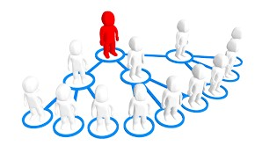 The ultimate outcome of relationship marketing is the building of a unique company asset called a **“marketing network”** A marketing network consists of the company and its customers, suppliers, distributors with whom it has built mutually profitable business relationships.

*Consider any business organisation that you are currently engaging with. Are they practicing relationship marketing with you? If so how? According to your own evaluation, which type of a customer you are? (true friend, stranger, barnacle, butterfly). Try to recognise some other*



1.4

*customers in the same business who belong to other relational groups and try to understand how does the business organisation maintain relationship with them? Is it different to yours?*

## 1.12 Marketing Management Process

Marketing process includes ways in which value can be created for the customers to satisfy their requirements. It is an endless series of actions and reactions between the customers and the companies making attempt to create value for and satisfy the needs of customers. In marketing process, the situation is examined to identify opportunities, the strategy is formulated for a value proposition, tactical decisions are taken, plan is executed, and results are monitored.

**Marketing Management Process**



-

Importance

core

and

concepts

of

Marketing

-

Core

of

concepts

Marketing

-

Company

orientatio

n

the

towards

marketplace

-

Marketing

Management

tasks,

developing

marketing



-

Gathering

information

and scanning

the

environment

-

Analysing

consumer

markets and

connecting

with

customers

-

Analysing

competitors

and

developing

SC

A



-

Identifying

market

segments and

select market

targets

-

Analysing

differentiatio

n

dimensions

and

developing

positioning

strategies



-

Product;

Designing

and

managing

market

offerings

-

Pricing;

Create value

-

Place;

delivering

value

Promoti

on;

communicati

ng value



Module 01



Module 02



Module 03



Module 04



Understandin

g Marketing

Management



Capturing

Market

Insights/Identi

fying

Marketing

Opportunities



Selecting

target

Market

Strategies



Developing

Marketing

Programmes



Manag

ing

the

Marketing

Efforts and

Marketing &

society



Module 05



-

Implementati

on marketing

programs

-

Controlling

marketing

programs

-

Managing a

holistic

marketing

organisation

for the long

run

Assume that you are working as a marketing manager for the ‘My Kitchen’; a newly established restaurant located in Nugegoda, which provide dinner menus in the restaurant premises as well as deliver to customer doorsteps upon their request.



***Think***

***Deep***



You are supposed to recognise the possible approaches to enhance ‘Customer Delivered Value’ and ‘Customer

Satisfaction’

**Chapter Overview**



# Marketing Philosophies/ Marketing Orientations

The purpose of this chapter is to enhance your understanding about different marketing philosophies that have been embraced by marketers (organisations) during the evolution of the marketing discipline. The chapter elaborates six such marketing philosophies used by marketers with an explanation of the major assumptions and the key focus areas of each philosophy. Students are also guided to reflect critically on each philosophy in terms of the validity of each in the current marketing environment taking the customers’ aspirations, long-term social wellbeing, and the sustainability issues into consideration.

## Learning Outcomes

At the end of this chapter you should be able to,

* Define each philosophy
* Describe the major assumptions and the key focus areas of each of the philosophies
* Understand different contexts that each philosophy emerged
* Explain the validity of each philosophy in the current marketing environment with reasoning
* Review each philosophy in terms of the aspirations of different stakeholders

### 2.1 Introduction to Marketing Philosophies

Marketing is an art as well as a science of choosing target markets and attracting, keeping, and growing customers through creating, delivering and communicating superior customer value1. Accordingly, Marketing management is recognized as one of the functional processes of an organization. It is a conscious effort to achieve desired exchange outcomes with target markets.

However, the question is what would guide a company’s marketing efforts? What is the relative emphasis the company gives to the conflict interests of the organization, the customers, and society? Further, the marketing activities of the company should be carried out under a well thought out philosophy that helps achieve efficiency, effectiveness, and social responsibility. Moreover, literature on marketing theory recognize marketing as an organizational philosophy or

“an approach to doing business.

Marketing is a management process whereby the resources of the whole organization are utilized to satisfy the needs of selected customer groups to achieve the objectives of both parties. Marketing then, is first and foremost an attitude of mind rather than a series of functional activities (McDoanls,1989, p.8).

Marketing is so basic that it cannot be considered as a separate function on a par with others such as manufacturing or personnel. It is first a central dimension of the entire business. It is whole business seen from the point of view of its final results, that is, from the customers’ point of view (Peter Drucker (1973).

11 Kotler P, Marketing Management, 11th edition (2003) p.9

**2.2 What is a Marketing Orientation?**

An orientation/a marketing philosophy is an assumption or belief, often unconscious, about the nature of the world. There are six competing orientations under which organizations carry out their marketing activities. In a way, these orientations represent as to how firms view their markets. The following diagram shows the six marketing philosophies.

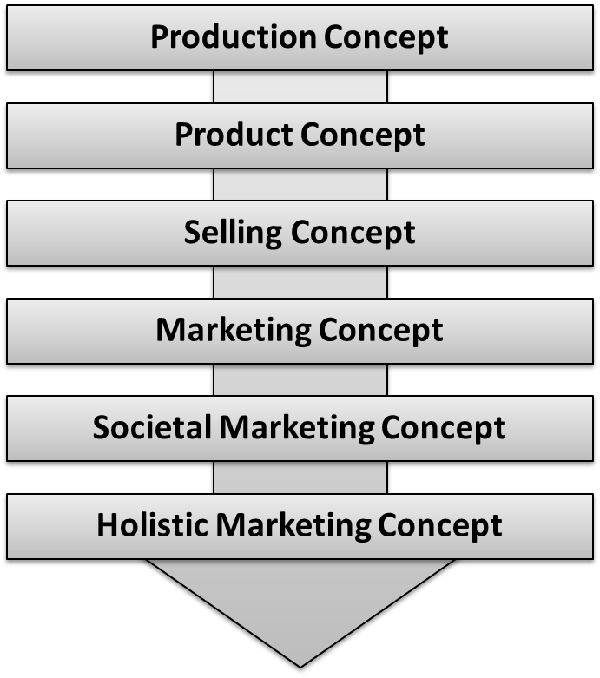

### 2.3 The Production Orientation

*The production concept holds that consumers will favour products that are available and highly affordable.*

Marketers who are guided by this philosophy focus on improving production and distribution efficiency. As such, marketers are directed to produce the product in large volumes (mass production), to use mass distribution to sell the product to all the consumers and to adopt mass communication to inform about the product to all the potential consumers in the market. This

overall practice is identified as ‘mass marketing’.

Hence,

mass

marketers

typically offer one standardised product

(

produced in large volume) to all the

consumers (e.g. Model T car offered by

Ford Company). However, the validity of

this philosophy has largely decl

ined in

tod

ay’s marketing environment.



Mass Production



Mass Distribution



Mass Distribution

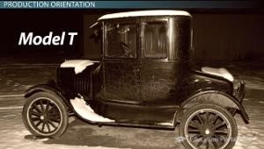

*Identify business/public organizations which still use the production philosophy in their day-to-day functions.*



2.1

*Explain why such organizations use production orientation even today (i.e. what are the conditions*

*that support the use of this philosophy?)*

### 2.4 The product Orientation

*The product concept holds that consumers will favour products that offer the most in quality, performance, and innovative features.*

This orientation leads a company to strive constantly to improve the quality of its product assuming customers admire and prefer to buy such products. However, such efforts would end-up with

‘marketing myopia’ i.e. too much focus on the product rather than on the consumer needs it presumes to satisfy.

A product-oriented marketer falls in love with its product and may improve it far beyond its worth to the consumer, passing the unneeded quality or special features through to the public resulting in too technical, highly sophisticated, and over-engineered products. Hence, organization must learn to think of itself not as producing goods or services but as providing solutions to needs (i.e. business is a need satisfying process rather than a manufacturing process).

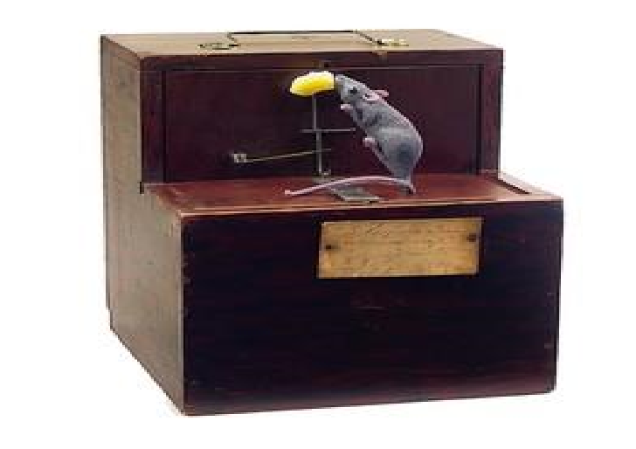

*People do not want a better mousetrap, but they want a better solution to the mouse problem.*

*Prepare a list of companies which always offer products with high quality and/or performance according to your understanding. Do you think all these companies/brands follow the product orientation? Why or why not?*



2.2

### 2.5 The Selling Orientation

*The selling concept holds that consumers will not buy enough of the firm’s products unless it undertakes a large-scale selling and promotion effort.*

The implicit assumption in the selling concept is that consumers are unlikely to buy a product unless they are actively and aggressively persuaded to do so. Further, it assumes that, though the consumers are disappointed by the product, they will forget it and tend to buy the product again.

The problem with a selling orientation is that it does not take consumer satisfaction into account.

Its aim is to sell what it makes rather than make what the market wants. If customers are induced to buy a product that they do not want or need, their unhappiness is likely to be communicated through negative word of mouth that may discourage other potential customers.

1. *Do you think the two assumptions of the selling*

*orientation are realistic to the modern-day consumption?*



2.3

*Why or why not?*

1. *Suppose a company which is facing a severe competition in the market spends a large budget on advertising and promotional activities annually. Is it fair to conclude that the company is adopting the selling philosophy? Why or why not?*

1. *Identify situations where the selling orientation still seems to be widely applied.*

### 2.6 The Marketing Orientation

*The marketing philosophy holds that achieving organizational goals depends on knowing the needs and wants of target markets and delivering the desired satisfactions better than competitors do.*

Adam Smith (1776) said that consumption is the sole purpose and end of production. He was in fact describing what, in recent years, has become to be known as the marketing concept. The key assumption that underlines the marketing concept is that, to be successful, an organisation must understand the needs and wants of specific target markets and deliver the desired satisfactions better than the competitors. Hence, marketing concepts highlights a more focused approach of marketing to satisfy target markets instead of offering a standard product to the entire market i.e. mass marketing. Marketers generally believe that target marketing is a better and a more profitable approach than mass marketing.

As such, the marketing concept rests on four main pillars: (a) Target Market (b) Customer Needs (c) Coordinated Marketing (d) Profitability, which are briefly elaborated below.

**Target Market (Market Focused):**

Market focus is concerned with careful identification and definition of target markets in which a firm can market its marketing mix profitably. Target market means a fairly homogeneous group of customers to whom a company wishes to appeal on the ground that they can be better satisfied, and the firm can earn better profits by serving the market.

**Customer Orientation (Need):**

Customer orientation is concerned with careful and precise understanding of needs of the target market and defining needs from the target market’s point of view. Theodore Levitt (1960) eloquently arguing the importance of the customer orientation says, “a truly marketing minded firm tries to create value satisfying goods and services that consumers will want to buy. What it offers for sale includes not only the generic product or service, but also how it is made available to the customer, in what form, when, under what conditions, and at what terms of trades.

Most importantly, what it offers for sale is determined not by the seller but by the buyer. The seller takes his/her cues from the buyer in such a way that the product becomes a consequence of the marketing effort, not vice versa.” In doing so, marketers attempt to understand ‘stated needs’, ‘real needs’, ‘unstated needs’, and even ‘secret needs’ though customer feedback and research.

**Coordinated (Integrated) Marketing:**

Since marketing is a philosophy it encompasses the entire organization. All departments of the company should be aimed at satisfying customers at a profit. Thus, the marketing and the other functions of the organization should be coordinated from the customer’s point of view. To that end, the marketing concept helps the organization work as a total system or a team making all the sections and departments customer focused. It specifies a high-level objective – customer satisfaction – that is logical for each and every part of the system.

When all departments of the business firm get together, they are more powerful and stronger than they work alone to better satisfy customers. Effective team members are committed to the firm’s success. They share common values, attitudes, and norms regarding product safety and customer satisfaction and accept and share responsibility for satisfying customer needs and wants profitably. These characteristics are essential for delivering a greater customer satisfaction in a complex and dynamic environment.

**Profitability:**

Profits are a requisite of business. Without profits, business would not be able to sustain its operations. Like food for the body, profits for the business is the excess of what comes in over what goes out. In business, it is called positive cash flow. Profit should be earned as an outcome of satisfying customers better than competitors can. Simply, marketing is satisfying consumer need with a profit. Thus, marketers must be involved in analysing the profit potential of different marketing opportunities. Therefore, marketers should have both market sensing skills (i.e. analysing and identifying marketing opportunities) and market relating skills (i.e. ability to design effective marketing strategies and programs to capitalise such opportunities).

1*.Differentiate marketing orientation from selling orientation on (a) start (b) focus (c) means and (d) end. (Refer to the relevant chapter of the recommended textbook to find the relevant framework and the answer).*



2.4

*2. ‘Through marketing orientation, some companies have been making huge profits by actually satisfying customers. However, marketing orientation is not recognized as the best philosophy that marketers and a broader society can foster’. Provide some valid arguments and evidence to support this claim.*

### 2.7 The Societal Marketing Orientation

*The societal marketing concept holds that the organization’s task is to determine the needs, wants, and interests of target markets and to deliver the desired satisfaction more effectively and efficiently than competitors in a way that preserves or enhances the consumer’s and the society’s long-term well-being.*

The societal marketing concept calls upon marketers to balance three considerations in setting their marketing policies: company profits, consumer wants, and society’s interests. Originally, most companies based their marketing decisions largely on short-run company profits. Gradually, they began to recognize the importance of satisfying consumer needs and wants, and the marketing concept emerged. Now many companies are beginning to think of social aspirations in addition to fulfilling customer requirements when making their marketing decisions

**Three considerations underlying societal marketing concept:**



**Customers**

**(**

**Satisfying need**



Societal

Marketing



**Compan**

**y**

**Objectives**



**Long**

**-**

**term Social**

**wellbeing**

*S*

*ource: Philip Kotler,*

*Principles of marketing,*

*(*

*Prentice hall, Inc.1994)*

*p.15*

1. *It is obvious that companies can run the business by using the marketing philosophy since it helps generate sufficient profits to the company through greater customer satisfaction. If so, do you think whether it is desirable for companies to adopt the societal marketing philosophy? Give valid reasons*



2.5

*to justify your answer.*

1. *Provide various ways/activities that a company can use to embrace the long-term social wellbeing.*

### 2.8 The Holistic Marketing Concept

In today’s complex business environment, businesses now need a holistic approach to meet new challenges better rather than the application of traditional marketing concept, which focuses more on customers and competitors only. Marketers need a fresh thinking about how to operate and compete in the new marketing environment. The need for having a more complete and cohesive approach gave the birth to a new marketing philosophy called ‘the holistic marketing’ and it recognizes that “everything matters” with marketing and that a broad, integrated perspective is often necessary. This is due to the fact that, to succeed in this highly dynamic environment, marketers have to deal with a variety of stakeholders such as consumers, competitors, suppliers, intermediaries, other functional departments of the organisation, ‘employees and labour unions’, owners, public groups, government and various pressure groups etc.

The holistic marketing embraces four components to the marketing practices:

* Relationship Marketing
* Integrated Marketing
* Internal Marketing
* Socially Responsible Marketing

#### Relationship Marketing (RM)

RM is to establish, maintain and enhance relationships with customers and other partners at a profit, so that the objectives of both parties involved are met. This is achieved by a mutual exchange and fulfilment of promises’ (Lovelock et al. 2001, p. 139).Thus,relationship Marketing has the aim of building mutually satisfying long-term relationships with key parties-customers, suppliers, distributors, and other marketing partners. RM builds strong economic and social ties among the parties thus forming strong strategic networks to compete with competitors.

#### Integrated Marketing

Integrated marketing simply means that there should be a good integration among various marketing tools and strategies used by marketers. For example, sound integration is needed among marketing communication tools such as advertising, personal selling, and sales promotion etc. Similarly, there should be a proper match among the 4 Ps i.e. product, price, place, and promotion.

Hence, integration marketing requires two things:

* A combination of marketing tools, variables or strategies needed to give a full impact on customers
* There should be a good integration; for example, all the communication tools must give a unified message (one voice)

Accordingly, integrated marketing acknowledges that many different marketing activities communicate and deliver value, and highlights the necessary to design and implement one marketing activity with all other activities in mind (when coordinated, marketing activities maximize their joint effects).

#### Internal Marketing

The purpose of internal marketing is to ensure that everyone in the organization embraces marketing, including the senior management, other departments, and the employees. In particular, employees play a vital role in implementing marketing strategies and serving customers. Internal Marketing is the task of hiring, training, and motivating able employees who want to serve customers well. Thus, internal marketing primarily includes:

* Hiring smart and competent employees
* Training and retrain for professional development
* Motivating lavishly by rewarding for gains in client satisfaction, value, and focus.

#### Performance Marketing

Holistic marketing incorporates of understanding the returns to the business from marketing activities and programmes, as well as addressing broader concerns and their legal, ethical, social, and environmental effects. Performance marketing can be embraced by performing two broad areas:

* Financial Accountability (profit, customer base, brands, loyalty etc.), and
* Social Responsibility Marketing (Marketers must carefully consider their role in broader terms, and the ethical, environmental, legal, and social context of their activities)

Discuss the major trends that have made the societal marketing concept and the holistic marketing concept more attractive models for contemporary marketing managers?



***Think***

***Deep***

**2.1**



Discuss, to what extent, small and medium enterprises (SMEs) of Sri Lanka can adopt the societal marketing orientation?



**Analysing Marketing Environment**

## Chapter Overview

The chapter three of the course manual focuses on giving an understanding on analysing marketing environment. First, the chapter presents an introduction to the environment analysis. Then, it focuses on approaches that can be used to analyse the environment which includes ‘internal and external’ perspective and ‘micro and macro’ analysis perspective. Finally, the strategic outcome of an environmental analysis (SWOT analysis) is presented, explaining how to respond to such changes in the marketing environment.

## Learning Outcomes

At the end of this chapter you should be able to,

* Explain what marketing environment is
* Identify two approaches to analyse environment
* Understand the differences between micro and macro environment analysis
* Recognize the importance of analysing internal environment
* Identify main actors in the microenvironment
* Identify major forces in the microenvironment
* Conduct a SWOT analysis for a given organization
* Learn how to respond to environmental uncertainties

### 3.1 Introduction to Marketing Environment

By now, you have learnt about the basic concepts of marketing, the marketing process, and the marketing philosophies. Furthermore, you have learnt that marketing is aimed at satisfying human needs and wants while achieving the organization objectives. In order to be profitable in business activities, marketers must attract and build up relationships with customers by creating customer value and satisfaction. However, marketers cannot accomplish this task alone. This means that marketers cannot operate independent of the environment. They are surrounded by many other forces and actors. We call these surrounding forces and actors as

‘marketing environment’.

All the organizations exist in an environmental context. These organizations, no matter profit oriented or non-profit oriented take inputs from this environment and after the process, they offer output (products, services, communications, waste, environmental pollution etc.) to the environment. Thus, the environment in which the organizations exists, arouses lot of pressures and influences to them. Organizations do not face static environment and though they like or dislike, environment changes continuously. Today, business organizations are facing to a rapidly changing dynamic business environment. Actors (customer, competitors, suppliers, intermediaries, public and others) in the environment work with or against the company and major environmental forces (demographic, economic, social, political, natural, and technological) shape marketing opportunities, pose threats, and affect the company’s ability to build customer relationships. In this type of scenario, these organizations are compelled to analyse these environmental changes in an ongoing basis so as to respond them quickly and wisely. Environment scanning and adjusting the business to the environment has been cited as a major reason for successful businesses.

Furthermore, decisions regarding the 4Ps of marketing cannot be made in isolation from the changing environment. The environment of a company consists of a large range of factors and influences that may impact on its ability to serve its customers and survive in the long term.

The marketing environment does not actually form part of the marketing process; however, the environmental factors influence most aspects of the marketing process. Ex: Changing customer preferences, changing strategies of competitors etc. Thus, when planning and implementing marketing programs, marketers should have a thorough understanding of company’s marketing environment.

**Marketing Environment** – The actors and forces outside marketing that affect marketing management’s ability to build and maintain successful relationships with target customers (Kotler and Armstrong, 2016).

### 3.2 Approaches to Analyse Marketing Environment

It can be identified that there are different approaches to analyse marketing environment. The approach uses to analyse can be influenced by the purpose of the analysis. Two widely used approaches to analyse the marketing environment are;

* Internal and external environment analysis
* Micro and macro environment analysis

### 3.3 Internal and External Environmental Analysis

Starting point of the environmental analysis is to start form the organization itself. The effectiveness of marketing programs is affected by the internal environment of the company too. Internal environment of an organization consists of elements of an organization which are within the organization’s boundary. Management of the organization, employees, physical resources, departments, processes, systems, organization culture, and intangible resources such as brands create a company’s internal environment.

A Company's external marketing environment consists of the external stakeholders (actors) and forces that are external to the marketing management function of the firm and that impinge on the marketing managements' ability to develop and maintain successful transactions with its target customers. External stakeholders include customers, competitors, suppliers, intermediaries, and publics with whom organization have direct and two-way relationships. On the other hand, major environmental forces include demographic, economic, social, political, natural, and technological forces. With these forces, organization has indirect and one-way relationships.

*Note: Elements of an organization’s internal environment, external stakeholders, and major environmental forces will be discussed in detail under Micro and Macro Environmental Analysis.*

### 3.4 Micro and Macro Environmental Analysis

This approach emphasizes the distinguish of close of environment which directly influence the business and broader environment which indirectly affect all the actors in the microenvironment.

#### 3.4.1 The Microenvironment

Microenvironment consists of actors close to the company, that affect its ability to serve its customers. This includes the company, suppliers, marketing intermediaries, customers, competitors, and various public groups, which combine to make up the company’s value delivery network. The figure 3.1 depicts actors in the microenvironment.

##### Figure 3.1: Actors in the Microenvironment



**Marketing**



**Company**



**Suppliers**



**Marketing**

**Intermediaries**



**Compe**

**titors**



**Publics**



**Customers**

**The Company:** When designing marketing plans and programmes, marketers need to consider other company groups and resources as well. Top management, other departments, their resources and support, organizational culture, processes and systems influence the effectiveness of marketing effort of the Marketing department. Therefore, the marketing and non-marketing resources should be assessed by the marketer before planning and implementing marketing plans and programmes of an organization.

##### Figure 3.2: Company’s Internal Environment



**Marketing**



**Top**

**Management**



**Finance/**

**Accounting**



**Purchasing**



**Manufacturing**



**Organization**

**Culture**



**Employees**

The purpose of internal analysis is to find strengths and weaknesses of both marketing and nonmarketing resources. Thus, it is important to have a coordination between marketing and these non-marketing resources. The marketing management has some degree of control over these internal resources.

**Suppliers:** Suppliers of the organization consist of the parties who provide resources needed to produce goods and services. Also, they form an important link in the company’s overall customer value delivery network.

* Provide resources needed by the company to produce its goods and services
* Problems related with suppliers can seriously affect marketing - Rising supply cost may force price increases

In the present marketing context, marketers should treat their suppliers as partners who support in creating and delivering customer value.

**Marketing Intermediaries:** Marketing intermediaries help the company to promote, sell, and distribute its products to final buyers. They include;

* Resellers
* Physical distribution firms
* Financial intermediaries
* Marketing services agencies

**Competitors:** Competitors are the parties who serve the same target market with similar products and services. In other words, competition includes all the actual and potential rival offerings and substitutes that a buyer might consider. According to the marketing concept, to be successful in the marketplace, companies must provide greater customer value and satisfaction than their competitors do, and company must gain strategic advantages against their competitors to succeed.

Therefore, to plan effective marketing strategies, a company needs to find out all it can about its competitors. It must constantly compare its marketing strategies, products, prices, channels and promotions with those of close competitors. There are three steps involved in analysing competitors.

1. Identifying the company’s competitors

At first companies need to identify competitors. Identifying competitors seems like a simple task. However, it is the duty of marketing managers to clearly identify different as well as potential competition the company faces. There are different tools and techniques marketers and managers can use to identity competitors.

Accordingly, based on the degree of product substitutability, we can identify four levels of competition as mentioned below.

* + Brand competition
  + Industry competition
  + Form competition
  + Generic competition

1. Assessing competitors’ objectives, strengths, weaknesses, and reaction patterns. After identifying different levels of competitors, marketing manager need to assess them considering following areas,
   * + What are their objectives?
     + What does each competitor seek in the marketplace?
     + What is each competitor’s strategy?
     + What are various competitors’ strengths and weaknesses
     + How will each react to actions the company might take?

Furthermore, it is important for the company to identify the different positions occupied by different competitors in the market. There are four main positions can be identified in any market,

* + - Market leader
    - Market challenger
    - Market follower
    - Market nicher

1. Selecting which competitors to attack or avoid

Once the company has assessed its competitors, they will be able to identify different types competitors in relation to the company.

* + - Strong or weak competitors
    - Close or distant competitors
    - Good or bad competitors

Next, considering the level of influence, the company can decide which competitors should be attacked and which competitors should be avoided or ignored.

**Publics:** A public is any group that has an actual or potential interest in or impact on an organization's ability to achieve its objectives. Seven types of publics can be identified.

* **Financial Publics:** Those who can influence company’s ability to obtain funds
* **Media publics:** Groups that can carry news and information related to the company
* **Government publics:** Government actions, decisions, and policies that impact on the company
* **Citizen-action publics:** Consumer organizations, environmental groups, and others those who can question company’s marketing decisions
* **Local publics:** Neighbourhood residents and community organizations
* **General publics:** General public’s attitudes towards company’s products and activities
* **Internal publics:** Workers, managers, volunteers, and the board directors of the company

**Customers**: Customers can be introduced as the most important actors in the company’s microenvironment. The aim of the entire value delivery network is to serve target customers and create strong relationships with them. Marketers can think of any or all five types of markets that might purchase company’s goods and services.

##### Figure 3.3: Five Types of Customer Markets



**Consumers markets**



**Business markets**



**Reseller markets**



**Government markets**



**International markets**

*Select an app -based public transport service such as PickMe, Uber, operating in Sri Lanka. Identify elements of its internal environment and external stakeholders (actors) in its microenvironment. Briefly discuss their*



3.1

*implications on the marketing activities of the*

*organization.*

#### 3.4.2 The Macroenvironment

Macroenvironment consists of larger forces that affect the Company’s microenvironment which includes the company and other actors. These forces are out of control of the business. Scanning these macroenvironmental forces allow marketers to identify unmet needs and pertaining trends, which raise opportunities for marketers.

Six major macroenvironmental forces are shown in the figure 3.4 below. Even some big players in the market are subject to the influences of macroenvironment. Some influences of these forces are unpredictable and uncontrollable. However, influences of macroenvironment should be handled skilfully and carefully. Companies that understand and adapt well to their environments can thrive. Those who cannot adapt will face difficulties and failures.

**Figure 3.4: Major Forces in the Company’s Macroenvironment**



**Company**



**Demographic**



**Economic**



**Natural**



**Technological**



**Political**



**Social**

**and**

**Cultural**

##### 3.4.2.1 The Demographic Environment

Demography is the study of human populations in terms of size, density, location, age, gender, race, occupation, education, and other statistics. Demographic environment can be recognized as one of the important macro forces that marketers need to study. Because demographic environment involves people, and people make up markets.

In 2020, the world population has reached to 7.8 billion and it is expected to grow further. The world’s large and highly diverse population poses both opportunities and challenges. Specially changes in the demographic environment have major implications for marketers. Therefore, marketers need to be vigilant about changes or developments taking place in demographic environments of their markets. Some of the common demographic trends observable in the present world are identified below.

**Population growth and changing age structure:** Population growth and changing age structure of the population creates important implications for marketers. When studying population data, it can be identified that, world population is growing at a faster rate. However, different countries experience different population growth rates. Further, changes in age structure of the population can also be identified. Some countries have young population while others’ population is ageing. As well as growth of some segments in size and power and generational effects can also be seen across different countries in the world. Therefore, it is the duty of marketers to identify relevant changes in population or age structure in respective markets and come up with appropriate strategies to overcome difficulties and capitalize opportunities.

**Geographic shifts in population:** At present great migratory movements can be seen between and within countries. Shifting from rural areas to urban areas, as well as migrating from developing countries to developed countries are common today. People move between and within countries due to occupational, educational, and personal factors.

**Changing Family Structure:** Trends in the family structure of the market also vital for marketers to plan and implement effective marketing programs. The traditional household consists of husband, wife, and children (and sometimes grandparents). However, during last time periods, the traditional family has faced to some changes and challenges. When analysing this scenario, several trends can be identified which have strongly affected marketing of products. They are,

* Increasing the age of marriage
* Delayed in childbearing
* Married but no children / single kid families
* Increasing dual income families
* Changing household patterns
* Part-time jobs and businesses
* Nuclear families

**A better-educated, more white-collar, more professional population:** Sri Lankan population is becoming better educated. Opportunities for education are widened and tendency toward getting a good education has increased.

**Changing role of women:** Women’s role in the society has changed specially in the Sri Lankan context. More women are entering higher education compared to men, and also, they earn competitive to men. Further, women employment has also increased significantly. Specially, today more and more women can be seen as professionals, managers, administrators, as well as entrepreneurs or business leaders.

##### 3.4.2.2 The Economic Environment

Markets require buying power as well as people. The economic environment consists of factors that affect consumer purchasing power and spending patterns. Changes in the economic environment directly affect the purchasing power of customers and hence business policies, approaches and strategies.

Thus, marketers should track these changes by analysing,

* Changes in consumer spending
* Income distribution and income levels
* Cyclical trend of the economy
* GNP and economic growth rate
* Interest rate and savings
* Credit availability of the economy
* Inflation and unemployment rate fluctuations
* Balance of payment condition and foreign exchange fluctuations

##### 3.4.2.3 The Natural Environment

The natural environment involves the physical environment and the natural resources that are needed as inputs by marketers or that are affected by marketing activities. At the most basic level, unexpected happenings in the physical environment, anything from weather to natural disasters can affect companies and their marketing strategies.

Today, environmental sustainability has been one of the key concerns in the society. Concerns related to climate change, global warming, and environmental pollution have forced organizations to consider the negative effects of their business activities on natural environment.

Marketers should be aware of the trends in the natural environment.

* Growing shortage of raw materials
* The increased levels of pollution
* Increased government intervention in natural resource
* Movement towards environmental sustainability

###### Environmental Sustainability

An effort to create a world economy that the planet can support indefinitely. Environmental sustainability means meeting present needs without compromising the ability of future

generations to meet their needs.

##### 3.4.2.4 The Technological Environment

One of the most dramatic forces shaping people’s lives is technology. People have seen several wonders like internet, antibiotics, robotic surgery, smartphones, mobile communication, automobiles etc. Also, it has some negative creations such as nuclear weapons and chemical weapons. However, our attitude towards technology depends on whether we are more impressed with its blunders or wonders.

Technology affects businesses and organization in different ways; some businesses either manufacture or sell technological products, some use technology for their business processes or operations, and also technology can be used for marketing communication purposes. The technological environment changes rapidly. Every new technology obsolete old technology and the products based on it. Further it affects the entire business process of a company (inbound logistics, manufacturing, delivering etc.) and create new opportunities to reach new customers, satisfy them with better solutions and provide higher convenience for customers when making transactions, settling bills etc. Therefore, no doubt that, marketers must review these technological improvements in an ongoing basis to survive in the marketplace. Accelerating pace of change, increasing research and development expenditures by companies, increasing regulations on technological changes and focus on minor improvements are some trends accruing in this environment.

##### 3.4.2.5 Political and Legal Environment

Marketing decisions are strongly affected by developments in the political and legal environment. This environment is composed of laws, government policies and bodies, pressure groups that influence or limit various organizations and individuals in each society.

Marketers must abide by business regulations. Business legislation has been enacted for several reasons.

* To protect companies from unfair competition
* To protect consumers from unfair business practices
* To protect the interest of society from unbridled business behaviour.

The effects of legislations on businesses have steadily increased over the years. Companies have to face immerging new legislations always. Therefore, they must have a good working knowledge of the major laws protecting competition, consumers and society. Governments tend to change their policies over the years, establish new agencies and bodies, which regulate business activities. Marketers should review those influences and respond properly. Further marketers have to respond increasing emphasis on ethics and social responsibility, which are highly created by various influencing groups such as envier mental protecting groups etc.

**3.4.2.6 Social and Cultural Environment**:

Cultural and social impact on business is a major factor to which marketers must pay greater concern. Social organizations such as family, school and temple and culture of the society shape beliefs, norms, values and behaviour of people. The ways of fulfilling their needs and wants are learned by people mainly through their culture. The way we dress at various places, what we eat, how our conduct should be at certain places etc. are taught by such social organizations. Therefore, when a marketer is trying to satisfy customers’ specific need, it must consider these cultural and social impact on the marketing program planned. In analysing these influences, marketers should understand high persisting core values of people, changing secondary values and existing subcultures and their impact.

* The people living in a particular society hold many core beliefs and value that trend to persist. Core beliefs and values passed on from parents to children and reinforced by major social institutions- Schools, Churches, and government etc. Core cultural values have high persistence and marketers cannot do against these core values.
* Secondary values are more open to change. These are the values which are open to change or cultural swings. E.g. Hair styles, clothing, sexual norms etc. marketers make use of these cultural changes to find new marketing opportunities.
* Existence of Subcultures. Each society contains subculture, which is a group with shared values, emerging from their special life experiences or circumstances. Eg. Hindu subculture, Buddhist subculture etc. As each subculture show different wants and consumption behaviors, marketers have to study them and use when take their marketing decisions.

*Recognise major macro environmental trends in present Sri Lankan context that would influence app -based public transport service companies given in the activity 3.1.*



3.2

### 3.5 SWOT Analysis

WOT Analysis is the strategic outcome of the environmental analysis. Based on the findings of the micro and macro analysis, SWOT analysis can be performed. By analysing the internal organizational environment, strengths and weaknesses can be identified and from the external environment analysis, opportunities and threats can be identified. Once SWOT analysis is conducted, it is the duty of marketing and other managers to develop strategies to capitalize opportunities, minimize the impacts of threats and overcome weaknesses.



**Strengths**



**Weaknesses**



**Opportunitie**

**s**



**Threats**



**SWOT**

#### Figure 3.5: SWOT Analysis

*Refer the scenario given in the question number one (01) in MAR 2340-Marketing Management, Year - II, Semester - I End Examination paper –August 2020, and answer the following questions.*



3.3

1. *Describe the importance of scanning the marketing environment for an entrepreneur such as Santhush and list down Strengths, Weaknesses, Opportunities and Threats (SWOT) identified by him during his environment analysis.*

1. *Suggest appropriate strategies based on the insights obtained from SWOT analysis.*

### 3.6 Responding to the Marketing Environment

When observing how companies respond to environmental implications, it can be noticed that different companies are responding to the marketing environment differently. Some companies view the marketing environment as an uncontrollable element. Therefore, they react and adapt to the forces in the marketing environment. Accordingly, they develop strategies to avoid threats and maximize opportunities. Other set of companies being proactive, take aggressive actions to affect forces in the environment, they develop strategies to change the environment. Some others take a reactive approach. They take aggressive actions to affect the publics and forces in their marketing environment.

By taking actions, companies are able to overcome seemingly uncontrollable environmental events. However, marketing managers cannot control their environments, especially major forces, all the time. In such situations, it is advisable to watch and react to situations. But whenever possible, marketing managers should take proactive approaches rather than reactive approaches to the influences of the marketing environment.

Discuss possible marketing implications of below environmental conditions on relevant business

organizations operating in the Sri Lankan market.



**Think**

**Deep**



1. Increasing shifts of population to urban areas
2. Growing Sri Lankan middle class
3. Import controls by the government
4. Growing tech savvy consumer groups
5. Society’s orientation towards comfort or luxury lifestyles.



**Managing the Marketing Information System**

## Chapter Overview

Chapter four focuses on giving an understanding of the marketing information system of an organization. First, the chapter gives an introduction on marketing information system and then the role and importance of marketing information systems are explained. Next, three main functions of a marketing information system: assessing information needs; developing information; and analysing and using information are explained.

## Learning Outcomes

At the end of this chapter you should be able to,

* Define what marketing information system is
* Understand the importance of marketing information system in managing the company marketing efforts
* Understand three main functions of a marketing information system
* Recognize three main approaches to develop marketing information • Understand the marketing research process

### 4.1 Marketing Information and Customer Insights

Good products and marketing programmes begin with good customer information.Today’s companies seek vast amount of information on competitors, marketing intermediaries such as resellers, and other actors and forces in the marketplace. Specially, to create value for customers and to build strong relationships with them, marketers must need to gain a comprehensive understanding on real needs and wants of customers. To gain that understanding, marketers need to have information which help them to gain competitive advantages as well.

Sometimes, these valuable insights are not freely or widely available in the environment and, finding such information can be a very difficult task. Some information are in the minds of customers, some customers can’t exactly tell what they really need or want or some information are kept as secrets by competitors. Therefore, under these situations, companies need to pay a considerable attention and effort in this. However, today, with the recent developments in information technology, companies are in a better position to gather and manage information from a wide variety of sources. Apart from traditional marketing research or surveys, current developments in technology have opened direct and easy access to new and strategically important information sources. As examples, sophisticated company information system itself help to generate huge amount information related to customers and markets. Further, internet, social media such as Facebook, twitter, and Instagram, emails, blogs, as well as even consumer online conversations about companies and products generate lots of important information related to customer behaviour, preferences, competitors and developments in the current environment.

Customer Insights – Fresh understandings of customers and the marketplace derived from marketing information that become the basis for creating customer value and relationships.

Accordingly, it is obvious that there should be a proper system to ensure continuous flow of right information for decision makers (marketing managers). Under these contexts, the concept of

‘Marketing Information System’ (MIS) has come to the front with the aim of providing *right information, in the right form, at the right time to the right people* for right decision making.

### 4.2 Marketing Information System (MIS)

According to Kotler and Armstrong (2016), a marketing information system is defined as “People and procedures dedicated to assessing information needs, developing the needed information, and helping decision makers to use the information to generate and validate actionable customer and market insights”.

From the figure 4.1, it can be identified that the MIS begins and ends with information users such as marketing managers, brand managers, internal and external partners, and others who use marketing information. First, the MIS identify marketing information requirements from information users, then based on their requirements, it will develop required information through internal company databases or marketing intelligence or marketing research. When developing marketing information, MIS has to interacts with the marketing environment of the company.

Accordingly, three main functions performed by the MIS are,

* Assessing information needs
* Developing needed information
* Analyse and use information

#### Figure 4.1: Marketing Information System

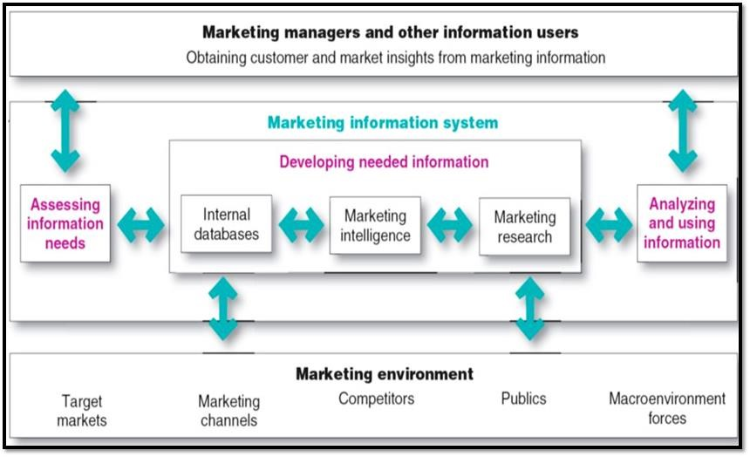

However, different companies may have different arrangements to manage their marketing information systems depending on their financial capability, scale of the business, nature of industry, nature of information requirements, etc. Also, different positions such as Chief Information Officer, Information Manager, Marketing Information Manager, Information Executive, Director - Research, Manager – Research, Research Executive can be seen at organizations when managing marketing and other information systems.

### 4.3 Functions of a Marketing Information System

Marketing Information system performs three main functions. They are,

* Assessing Information needs
* Developing needed information
* Analysing and using information

#### 4.3.1. Assessing Marketing Information Needs

Marketing Information System (MIS) should first identify the information requirements of the users of such information. MIS provides information to the company’s marketing and other managers and external partners such as suppliers, resellers, and marketing service agencies. Assessing information needs can be based on the requests of information users or by the company MIS itself.

A good MIS balances the information users *would like to have* against *what they really need* and *what is feasible to offer*. Because, some information users or managers may request more information than what they really need to solve their issues. Also, some others may not identify their information requirement clearly and omit some important information they should have to find solutions for their issues. Further, in some instances, there can be some information that are very difficult to gather or uncover (Ex- consumer attitudes, buying motives, etc.). Therefore, it is the duty of MIS to manage these issues through consulting and guiding, when assessing real information needs of information users.

In addition to the above concerns, MIS needs to consider about the cost of obtaining some information as well. The company must decide whether the cost incurred to obtain some information is justifiable compared to the value of the insights the company gained from the information. Sometimes, some organizations may not in a position to invest in surveys/ research or any other information developing activities due to high cost, even though such information are really useful for decision making purposes.

##### Figure 4.2: Balancing User Needs versus Real Information Requirements

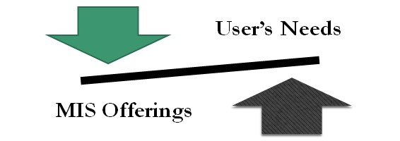

#### 4.3.2 Developing Marketing Information

There are three approaches that marketers can use to obtain needed information.

* Internal data
* Marketing Intelligence
* Marketing Research

##### Internal Data

Information obtained from data sources *within the company network* is known as internal data. Any organization has its own systems to record information generated through their day-to-day activities such as sales, revenue, profits, consumer characteristics, products’ data etc. Accounting department may provide details related to different costs and expenses. Also, operations department may provide details related to production, inventories, shipments, etc. Therefore, there can be number of internal data sources within the company’s network that can be used to generate important insights for marketing decision making requirements. Thus, these internal data reveal *what has already happened.*

There are some advantages of using internal data sources to develop marketing information, compared to other information developing approaches. One of the main advantages is ability to access quickly and economically as they are available within the company network. However, these data are not collected for the problem at hand, they are collected or generated for some other purposes. Therefore, the data may not be current or perfectly matching with the information requirement. However, to collet, store, and manage these data requires a considerable amount of effort and money.

*Taking a tourist hotel as an example, identify different marketing information available within its internal company network that can be used for marketing decision making.*



4

.1

##### Competitive Marketing Intelligence

Competitive marketing intelligence is the systematic collection and analysis of publicly available information about consumers, competitors and developments in the marketplace (Kotler and Armstrong, 2016). The goal of competitive marketing intelligence is to improve strategic decision making by understanding the marketing environment, assessing and tracking customers’ as well as competitors’ actions and providing early warnings of opportunities and threats. Thus, information developed through competitive marketing information reveal *what’s going on* and *what will happen*.

Developing competitive marketing intelligence involves a considerable effort and sometimes cost compared to internal data. Further, competitive intelligence is also developed for some other purposes. However, competitive intelligence consists of current and updated information related to trends and developments in the company’s marketing environment. Organizations use different sources or techniques to develop marketing intelligence. Some of marketing intelligence sources used by organizations are mentioned below.

##### Marketing Intelligence Sources

* Observing consumers
* Quizzing the company employees
* Benchmarking competitors’ products
* Researching the internet
* Monitoring internet buzz
* News and publications
* Key customers

* Suppliers and resellers
* Government agencies
* Competitive analysis
* Trade associations
* Information companies
* Sales force as “eyes and ears” ▪ Ghost shopping
* Searching competitors’ garbage

Due to recent developments in information and communication technologies, present companies are easily accessible to some information sources where they can gain important insights related to customers, competitors, and markets. Specially, growth of social media has paid new ways to study consumers and their behaviours. Today companies can see what consumers have expressed regarding their products, services, brands, as well as competitors. Also, companies can identify how consumers connect and engage with brands in these platforms. Further, companies are in a position to monitor consumers’ online conversations with other consumers.

Therefore, it can be identified that this new media environment has created access to real consumer, market, and competitor information than ever before. However, organizations need to make sure that appropriate people, processes, systems, or methods are in place to capture such important information.

*A leading hotel chain in Sri Lanka is planning to establish a new tourist hotel in Ella. As a member of the management of the hotel chain., identify possible marketing intelligence sources that can be used to find some important marketing*



4.2

*information to facilitate decision-making purposes.*

##### Marketing Research

In some instances, the company MIS may not be in a position to satisfy some information seekers’ information requirements from internal data or competitive marketing intelligence. In such situations MIS needs to conduct formal studies which focuses on specific issues related to consumers, markets, or competitors. These formal as well as scientific studies are known as marketing research. Marketing Research is defined by Kotler and Armstrong (2016) as “*the systematic design, collection, analysis, and reporting of data relevant to a specific marketing situation facing an organization”.*

Marketing research can be conducted for different situations faced by the organization. For examples, to identify the impact of service performance on customer satisfaction, to identify customer motivations, to examine the effect of advertising on purchase behaviour, to assess brand awareness and brand equity, to assess the effectiveness of marketing strategies etc

Also, compared to other two information developing approaches, marketing research usually incurs a considerable cost and effort. Some organizations have their own research departments/ divisions/ units within the marketing department or within the organization where even marketing research projects are also carried out. However, many other organizations are used to get the service of external research companies to conduct their research projects. Some companies outsource the entire research project from external parties and others outsource only some parts of the project such as data collection, data analysis, administering the survey, etc.

The marketing research follows a systematic process which includes four steps: defining the problem and research objectives, developing the research plan, implementing the research plan, and interpreting and reporting the findings. The figure 4.3 depicts the marketing research process.

**Figure 4.3: The Marketing Research Process**

Defining the

problem and

research objectives

Developing the

research plan

Implementing the

research plan

Interpreting and

reporting the

findings

##### Step 1: Defining the Problem and Research Objectives

The first step is to define the problem at hand. When defining the research problem and setting research objectives, both parties, marketing managers and researcher should work closely. Because, managers have a better understanding regarding the problems that company faces, while researchers have a sound knowledge on the marketing research and relevant techniques.

The management or decision problem has to be converted to a research problem. A well-defined problem is half solved. The research problem should be defined neither too narrowly nor broadly.

Then research objectives have to be outlined. These can be given as research questions.

Accordingly, the problem statement and the objectives guide the entire research process.

##### Step 2: Developing the Research Plan for Collecting Information

After defining the research problem and objectives, researchers need to determine the exact information requirement for the research. Then, the most efficient plan for gathering needed information should be developed.

The research plan should outline,

* Data source
* Research approach
* Contact methods
* Sampling plan
* Research instrument

##### Step 3: Implementing the Research Plan

Step three of the marketing research process involves collecting, processing, and analysing data. These activities can be done by the company or outside research firms. This phase of marketing research is generally the most expensive and the most prone to error. Therefore, researchers must closely observe data collection process, specially whether the data collectors perform their task genuinely as instructed.

Once the data collection is over, collected data should be entered to respective systems or software for processing and analysis. There, the accuracy and the completeness of data should also be considered by the researcher. According to the objectives of the research, relevant data analysis techniques should be determined.

##### Step 4: Interpreting and Reporting the Findings

Last step of the marketing research process involves interpreting findings, draw conclusions, and report them to management. The researcher should present important findings and insights generated from the data analysis, which are useful for decision makers to find solutions to their problems. However, when interpreting findings researchers should get the involvement of managers to avoid possible misinterpretations. Further, researchers usually submit a report regarding the research project to the management of the company. **Figure 4.4: Researchers Should Be Careful When Interpreting Findings**

**Terrible market.**

**No one wear shoes.**

**Wonderful market !!**

**No one wear shoes.**

*Identify possible situations when following organizations should use marketing research to satisfy their information requirements.*



4.3

* *Fast food restaurant*
* *Commercial bank*
* *Biscuit manufacturer*
* *Government University*
* *Telecommunication service provider*

#### 4.3.3. Analysing and Using Marketing Information

Information gathered in internal databases, and through competitive marketing intelligence, and marketing research need further analysis before using for decision making purposes. Advanced data analysis techniques, models, and software can be used when analysing data to generate better insights. Once the information has been processed and analysed, findings should be made available to relevant decision makers at the right time. There won’t be any value with the marketing information, unless they are used for decision making purposes. Therefore, it is the responsibility of the Marketing Information System to make sure that generated marketing information make available to relevant decision makers without any delays.

Select any supermarket chain operating in Sri Lanka. Identify possible decision-making situations with the required marketing information under each information developing approaches mentioned below.



**Think**

**Deep**



* internal data
* marketing intelligence

* marketing research

# The Buyer Behaviour

**and Buying Process**

## Chapter Overview

The aim of marketing is to meet and satisfy target customers’ needs and wants. Therefore, the purpose of this chapter is to introduce the theoretical foundation of Consumer Behaviour, which helps marketers to comprehend how individuals, groups, and organizations select, buy, use, and dispose of goods, services, ideas, or experiences to satisfy their needs and desires. Understanding consumer behaviour is challenging as it encompasses knowledge from a variety of route disciplines such as psychology, sociology, economics and anthropology etc. This chapter describes the

‘cognitive’ decision making process of consumers and discusses how consumer decisions are influenced by cultural, social and psychological factors.

## Learning Outcomes

At the end of this chapter you should be able to:

* Define consumers and identify different types of consumers.
* Explain how consumers make a purchasing decision.
* Describe how involvement of consumers vary in different buying situations.
* Discuss how cultural, social, personal, and psychological factors influence consumer buying.

### 5.1. Introduction

Marketing philosophy states that organizations exist to satisfy consumers’ wants and needs. These wants and needs can be satisfied only to the extent that marketers can understand the people or organizations that may use the products and services. In order to fully understand customer needs and wants, a marketer has to be aware of the thinking and decision-making process of the consumer. Since it is impractical to study consumer-thinking process by dissecting the head, marketers study the behaviour of consumers. It is assumed that behaviour is the outward manifestation of mental intentions of a consumer. Therefore, by analysing consumer buyer behaviour, a marketer can understand the nature of thinking process of the consumer. Then, it is easy to match products to consumer needs. In this lesson, we attempt to understand the consumer decision making process and the factors that affect the decision process when making purchases.

**Consumer behavior is defined as:**

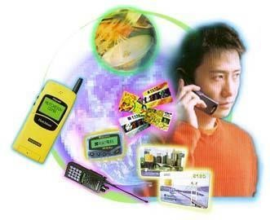*…….. the decision process and physical activity individuals engage in when evaluating, acquiring, using, or disposing of goods and services***.**

A simple but a profound way to understand buyer behaviour is to look it from a stimulus – response model.

All living organisms respond to internal stimuli as well as external stimuli. When certain stimulus is given human beings respond to it. Psychologists study this process to understand the human behaviour.

All living organisms respond to internal stimuli as well as external stimuli. When certain stimulus is given human beings respond to it. Psychologists study this process to understand the human behaviour.

The desired marketing response in this simple model may be,

* Buying a certain product
* Buying a certain brand
* Buying at a particular place
* Buying from a particular dealer

The marketing stimuli consists of the key marking strategies such as 4 P’s (Product, Price, Place, Promotion). Marketers want to know the exact bundle of stimuli that can receive a particular response from buyers. This knowing process is much more complicated, as human beings do not respond uniformly to the same set of stimuli given at two different intervals. This is because there is “buyer’s black box” (the head or the thinking process of the consumer).

The real challenge for any marketer is to understand the mechanism of buyer thinking process. The following buyer behaviour model will show the stimuli, the buyer black box (the head) and the possible responses.

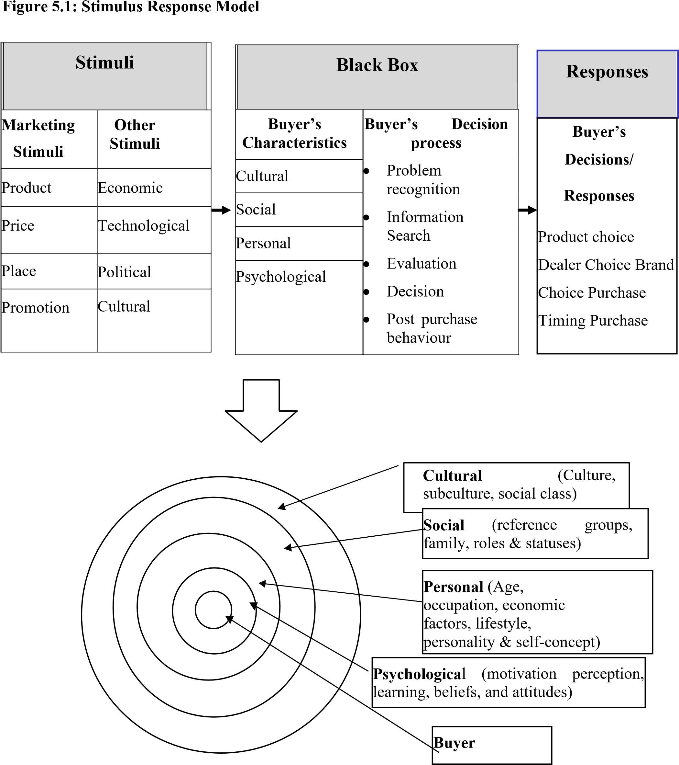

#### How and why consumers buy

The starting point for understanding consumer buying behavior is the stimulus response model shown in Figure 5.1. As this model shows, both marketing and environmental stimuli enter the buyer’s consciousness. In turn, the buyer’s characteristics and decision process lead to certain purchase decisions. The marketer’s task is to understand what happens in the buyer’s consciousness between the arrival of outside stimuli and the buyer’s purchase decisions. As this model indicates, a consumer’s buying behavior is influenced by cultural, social, personal, and psychological factors.

### 5.2. Buyer’s Characteristics

In the above model, it is clear that consumer responses to various stimuli are influenced by buyer characteristics and buyer decision process. Because, the buyer’s characteristics and decision process lead to certain purchase decisions. The following section will discuss in detail how each of the factors (buyer’s characteristics) presented in the model influences buying decisions.

#### 5.2.1. Cultural Factors

**Culture:** Culture is the most fundamental determinant of buyer behavior. It can be defined as the total of learned beliefs values, and customs that serve to direct the consumer behavior of members of a particular society. It is the general framework within which buyer-thinking process is operating.

**Subculture:** One social culture may be composed of different subcultures in a country. In a society, not all segments show the same cultural patterns. Therefore, we can distinguish more homogeneous subgroups within the heterogeneous national society. We refer to these groups as subcultures because they have values, customs, traditions, and other ways of behaving that are peculiar to a particular group within a culture. Buyer behavior tends to change according to these subcultures.

**Social Class:** The social classes also emerge as a subset of a country’s social culture. Social classes are relatively homogeneous and enduring divisions in a society which are hierarchically ordered and whose membership share similar values, interest, and behaviour.



**5.2.2. Social Factors:**

**Reference Groups:** Various groups can influence a person’s buying behavior. These groups have a direct or indirect influence on the person’s attitudes or behaviour.



Disassociate

Groups



Non

-

Membership

Groups



Aspiration Groups



Reference Groups



Membership

Groups



Secondary Groups



Primary Groups

Reference groups may influence buyers in many ways:

* Expose an individual to new behaviours and lifestyles
* Influence the person’s attitudes and self-concept
* Create pressures for conformity that may affect the person’s actual product and brand choices

**Family:** The family is the most important consumer buying organization in society. It is the nucleus of buying units. Family plays a vital role in socializing a person and thereby inculcating buying habits.

**Roles and Status:** People play different roles in the society and based on these roles they derive social status that influence a person’s buying decision.

#### 5.2.3. Personal Factors

Buyer decisions are also influenced by personal characteristics.

**Age and stage in the life cycle:** People buy different goods and services over a lifetime and consumption is also shaped by the family life cycle.

**Occupation and economic circumstances:** Product choice is greatly affected by economic circumstances: spendable income, savings and assets, debts, borrowing power and attitude toward spending vs. savings.

**Lifestyle:**

A lifestyle is the person’s pattern of living in the world as expressed in activities, interest and opinions.

**Personality and self-concept:**

Each person has a distinct personality that influences buying behavior. Personality can be defined as, distinguishing psychological characteristics that lead to relatively consistent and enduring responses to environment.

**5.2.4. Psychological factors:**

These factors include; (1) motivation (2) Learning (3) Beliefs and attitudes (4) Perception

**Motivation:** The root of motivation is a need that drives a person toward a goal directed action. The need drives a person to act or does not act in a certain manner. We call this “motivation”. Consumers buy goods and services to satisfy needs. Therefore, consumers are need-driven. Hence, to understand the consumer behaviour, we should study the root of consumer motivation. For this, there are theories of motivation such as Maslow’s hierarchy of needs, Herzberg’s two-factor theory, David McClelland’s Need theory etc. (Please refer these theories for further understanding).

**Learning:** Learning involves changes in an individual’s behaviour arising from experience. Most human behaviours are learned. There are several learning theories to explain the learning process of human beings. This understanding is important for a marketer to develop the marketing offers to suite the consumer tastes and preferences.

**Beliefs and attitudes:** A belief is a descriptive thought that a person holds about something. An attitude is a person’s enduring favourable or unfavourable evaluation, emotional feelings, and action tendencies toward some object or idea which is formed through beliefs. Beliefs and attitudes matter a lot when making the buying decisions. Therefore, marketers should be fully aware of the nature and formation of consumer beliefs and attitudes.

**Perception:** Perception is the internal representation of the external world by the consumer i.e., how a consumer creates a mental picture of what he grasps from the environment by his senses. Consumer perception should be the marketer’s reality. Otherwise, consumer will not buy the products that do not match his or her reality.

*A company has recently introduced a new*

*‘ready-to-drink milk’ made of coconut, which can be used as an alternative to cow milk. However, given the fact that coconut is mainly used for cooking purpose in Sri Lanka, consumers may not try this new product just after the launch of the product. Hence, the challenge for the manufacturer is to determine how to persuade their consumers to buy the product.*



5.1

*Discuss the factors that may influence consumers when making a purchase of a new product of this nature.*

### 5.3. Buyer Decision Process

Buyers pass several stages in buying products. However, whether a consumer passes all these stages or make quick decisions depends on the nature of the problem-solving process. i.e. extended problem solving or limited problem solving. The stages involved in the buyer decision process are described below.

#### Figure 5.2:Buyer Decision Process

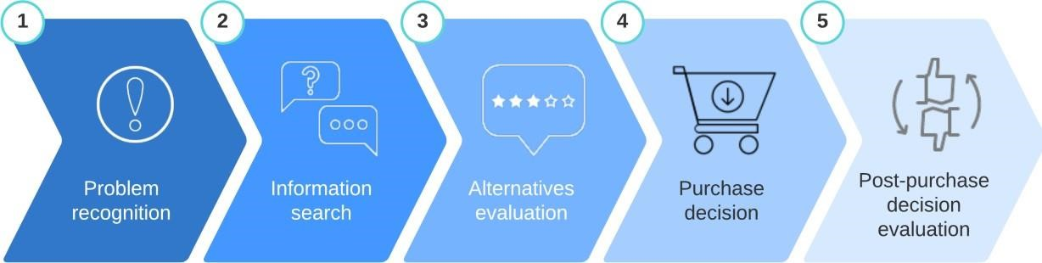

**Stage 1- Needs recognition:** The buying process starts when the buyer recognizes a problem or need. This need can be triggered by internal stimuli (such as feeling hunger or thirst) or external stimuli (such as seeing an advertisement) that then becomes a drive.

**Stage 2- Information search:** An aroused consumer who recognizes a problem will be inclined to search for more information. Consumers tend to look for information through various sources. These sources include personal sources (family, friends, neighbours), commercial sources (advertising, Web sites, salespersons, dealers, packaging), public sources (mass media), and experiential sources (handling a product, examining, using the product). Although the most influential information comes from personal sources, the consumer usually receives the more information from the commercial sources (marketer-dominated). Through gathering information, the consumer learns more about competing brands, products, benefits etc.

**Stage 3- Evaluation of Alternatives:** Once the information search is over, consumers tend to adopt a process of evaluation to select the best brad/product. This process is more cognitively oriented. This means that consumers make judgments about products largely based on a conscious and rational basis. In this stage, consumers tend to set an evaluative criterion based on their expectations (needs) and evaluate each brand/product against the set criteria. For example, the criteria in evaluating mobile phones may include battery life, size of the phone, price, colour, memory capacity, camera quality and brand image of the producer. It is however important to note that consumers (i.e., target markets) vary as to which product attributes they see as most relevant and the importance they attach to each attribute.

**Stage 4- Purchase Decision:** In the evaluation stage, the consumer forms preferences among the brands in the choice set and may also form an intention to buy the most preferred brand. In this stage, consumers make an effort to buy the chosen product or brand. However, their ‘intention’ to make the purchase may change last minute due to various factor such as immediate attitudes of significant others, competing offers of value at point of sale, sales person may not closing the sale correctly, perceived crowding of the retail outlet etc.

**Stage 5- Post-purchase Behaviour:** After purchasing the product, the consumer moves into the final stage of the consumer buying process, in which they would experience some level of satisfaction or dissatisfaction. Their level of satisfaction with the product consumed determines their future behavior (e.g., repeat buying, recommending to others).

By studying how consumers go through the decision making process, it is clear that that marketers have to play a key role in influencing consumers in the each stage of the decision making process and their job does not end when the product is bought. In particular, marketers must monitor post- purchase satisfaction, post-purchase actions, and post-purchase product uses too.

### 5.4. Level of Involvement and purchase decisions

The complexity of the decision-making process consumers go through depends on the level of product involvement as depicted by the diagram below:

#### High involvement Low involvement

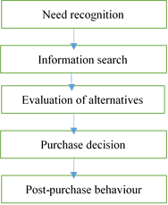

Efforts (such as time, resources) increases in decision making)

The important point is that the purchase type and situation will determine involvement level, which will affect the DMP (Decision Making Process). The higher involvement purchases generally mean that consumers go through every step of the DMP and often, over a long period of time, e.g., buying a car. Whereas, some steps may be skipped for routine purchases, e.g., milk.

*Do you think a consumer would go through all the*

*steps of the ‘buying decision process’ when he/she intends to purchase a mobile phone and have a meal from a local restaurant? Explain your answers using the relevant concepts.*



5.2

### 5.5. Types of Buying Behavior

Consumer decision-making varies with the type of buying decision. The type of product also plays a significant role. The figure below shows four different types of buying behaviour.

#### Figure 5.3: Types of Buying Behaviour

High Involvement Low Involvement

|  |  |
| --- | --- |
| **Complex buying behaviour** | **Variety seeking buying behaviour** |
| **Dissonance reducing buying behaviour** | **Habitual buying behaviour** |

Significant differences between brands

|  |  |
| --- | --- |
| Initiator | : the person who first suggests or thinks of the idea to purchase a product. |
| Influencer | : the person whose views and advice carry some weight in the buying decision. |
| Decider | : the person who ultimately makes the decisions (or part of it) - includes *whether/ what* / *how* / *where* to buy. |
| Buyer | : the person who makes the actual purchase. |
| User | : the person who consumes or uses a product. |

Few differences between brands

### 5.6. Buying Roles

Consumers play various roles in the buying decision process. They are; initiator, influencer, decider, buyer, user, discarder.

Discarder : the person who dispose of the product after consumption.

*Taking a scenario of online hotel reservation for a family trip during your holidays, discuss the implications for marketers in relation to buying roles and the types of buying decisions discussed above.*



5.3

Real-estate industry has vastly improved over the last few decades in terms of developing residence solutions for the market. From its humble beginnings of providing a ‘roof over head’ for people who are looking

***Think Deep***

**5.1**



for a place to stay. Yet, in today’s society, expectations

of consumers have gone far beyond a just a place to live when they buy houses.

Discuss how real estate companies can use knowledge gained under this topic when meeting the expectations of consumer to ensure to stay ahead of the competition in the market and achieve long-term success of the firm.

# Customer Driven Marketing Strategy: Segmenting, Targeting and Positioning

## Chapter Overview

Up to now, the course helped students comprehend what is marketing and the importance of understanding the marketplace and the opportunities emerging in the market place. In that background, the course now focuses on how to develop marketing strategies. Accordingly, this chapter looks further into key customer value–driven marketing strategy decisions—dividing up markets into meaningful customer groups (segmentation), choosing which customer groups to serve (targeting), creating market offerings that best serve targeted customers (differentiation), and positioning the offerings in the minds of consumers (positioning).

## Learning Outcomes

At the end of this chapter, students should be able to:

* Explain how and why segmentation is applied to consumer markets
* Determine the vatable to segment markets for their offer
* Apply the evaluative criteria for selecting appropriate target market for the offer
* Identify effective differentiations and develop a positioning strategy for their offer in the target market

### 6.1 Market Segmentation

A company cannot serve all customers in a broad market as customers are very numerous and diverse in their buying requirements. Therefore, a company needs to identify the market segments it can serve effectively and embrace on target marketing. However, before coming to this stage marketers had held other views too. Their thinking passed through three stages.

#### Mass Marketing

Here, the marketers try to sell their products to all buyers in the market. Normally those marketers engaged in mass production, mass distribution, and mass communication of one product. The rationale behind mass marketing was that it would lead to lower costs and prices so that company can obtain the largest market share. The guiding principle behind this strategy is production philosophy.

#### Product Variety Marketing

On the ground that customers prefer variety, marketers produced several versions of the product of different features, styles, sizes and so on. Instead of appealing to different needs of different segments, producers design some varieties of the product with the mindset that customers have different tastes and tastes change over time.

#### Target Marketing

Here the marketers try to distinguish differences of various customer groups and target one or more of these segments and design different marketing mixes tailored to each segment. Today’s companies have realized that mass marketing and product verity marketing no longer rewarding.

Thus, the trend is to practice target marketing. Target marketing calls for three major steps.

1. Market segmentation
2. Market targeting
3. Differentiation and positioning

#### Figure 6.1. Process of Target Marketing

|  |  |  |
| --- | --- | --- |
| **Market Segmentation** | **Market Targeting** | **Differentiation and Positioning** |

Identify possible positioning

options

Select, develop and

communicate the chosen

positioning strategy

Evaluating the segments

Select the target segments

Segment the market

Develo

p segment

profiles

The act of identifying and profiling distinct groups of buyers who might require separate products and / or marketing mixes.

**Why Segmentation?**

Markets consist of buyers and the differences among buyers such as purchasing power, geographical location, buying behaviours etc. will lead certain segments to require separate products/marketing mixes. Therefore, any of such variables can be used to segment a market.

*Consider yourselves to be part of the “mobile phone market” and reflect the following:*



6.1

1. *Which group/s (segment/s) do you think you belong to?*
2. *What do you all share in common?*

#### 6.1.1 Bases and Variables for Market Segmentation

Buyers in any market differ in their wants, resources, locations, buying attitudes, and buying practices. Through market segmentation, companies divide large, diverse markets into smaller segments that can be reached more efficiently and effectively with products and services that match their unique needs. The section below presents the variables that markets can use to divide consumers (markets) into segments and they are categorized under four areas:

* Geographic segmentation
* Demographics (age, income, gender etc.)
* Psychographics (attitudes, perception)
* Behavioural (media behaviour, buying behaviour etc.)

##### Figure 6.2: Bases for segmenting consumer markets

**Segmenting Variables**



Geog

raphic

Segmentation



Demographic

Segmentation



Psycho graphic

Segmentation



Behavioural

Segmentation



Age

Gender

Family Size

Family Life Cycle

Income

Occupation



Occasions

Benefits

User Status

Usage Rate

Loyalty Status

Region

City

Density

Climate

Social Class

Lifestyle

Personality

## Geographic Segmentation

Here, the marketers try to divide the market into different geographical units which tend to show buying differences.

For Example, regional wise (Asia, Atlantic), Density wise (urban, suburban, rural), Climate (hot areas, cold areas) etc.

This segmentation is appropriate for products like clothes, food, shelter,liquor etc.

## Demographic Segmentation

This is the most popular base for segmenting markets because consumer wants, and preferences are often associated with demographic variables. The other thing is that these variables are easier to measure. Thus demographic segmentation calls for dividing the market using demographic variables such as age, income level, occupation education, race and religion.

**Age and life cycle stage**:

Wants, preferences and buying behaviour change with age. Thus, this provides marketers with a useful way to segment the market. E.g. babies, youths, adults

This basis is highly used for such products such as clothes, food, haircuts, beauty products, toys

**Gender:**

This is also widely used by marketers to segment the markets for products such as clothing, hairdressing, cosmetics, footwear, and magazines.

**Income:**

This variable also has long been used to segment in such products as housing, clothing, cosmetics, and automobiles, travel etc.

**Family size**:

Small families with members 1-2, medium size families 3-5 and families of members than five (05).

**Family life cycle**:

Each life cycle stage reflects different buying behaviors. E.g., Young, single; young, married, no children; young, married, youngest children under 6; young, married, youngest child 6 or over; older, married, with children; older, married, no children under 18; older, single; other. **Occupation**:

Occupation reflects different status and roles which lead to arise different buying behaviours. E.g., Managers, professionals, lecturers, clerical, farmers, students, housewives, unemployed.

**Education:**

This variable is used in such products as education courses, training products, etc. E.g., primary education, secondary education, undergraduates, postgraduates.

**Religion:**

E.g., Catholic, Buddhist, Hindu, Islam.

**Ethnicity**:

Sinhalese, Tamils, Muslim

Racial and religious variables are used for such products such as clothing, food, religion, courses etc.

### Multi attribute Demographic Segmentation

To define target markets more accurately and effectively, most marketers tend to segment a market combining two or more demographic variables.

E.g. segmenting the market using age and gender, or age income and gender etc.

## Psychographic Segmentation

Here the buyers of the market are divided into different groups based on the variables such as social class, lifestyles, personality. Note that people within the same demographic segment might show different buying behaviours due to different psychographic profiles.

### Social Classes

Social classes are relatively homogeneous and enduring divisions in society which are hierarchically ordered and whose members share similar values, interests and behaviour.

E.g. upper class, middle class, lower class

Social classes have several implications on marketing.

Persons within each social class tend to behave more alike than persons from two different social classes.

Persons are perceived as occupying inferior or superior positions according to their social classes.

A person’s social class in indicated by a number of variables such as occupation, income, wealth, and education.

Social classes show distinct product and brand preferences in areas as clothing, housing, home furniture, leisure activities, and automobiles.

### Lifestyles

Lifestyles also have an impact on buying behaviour of the market. Sometimes people coming from the same social class show different buying behaviours due to different lifestyles.

Lifestyle is defined as the pattern of living in the world. Normally, lifestyle is expressed by the person’s activities, interests, and opinions. This segmentation is practiced by marketers for products as automobiles, apparel, cigarette, cosmetics, alcoholic beverages, leisure activities etc.

**Personalit**y. certain personality variables can be used to segment markets. Marketers try to match brand personalities with consumer personalities. E.g., authoritarian, masculine, self-confident etc.

## Behavioural Segmentation

In this way of segmentation customers are classified to groups according to their buying responses to a product.

**Occasions:**

Buyers are grouped according to the occasion when the buy or use the product. E.g., clothes for casual wear, clothes for special occasions etc.

**Benefits:**

A very famous way of segmentation of markets is that classifying consumers on the basis of benefits they seek from the product.

E.g., economy seeking buyers, quality seeking buyers, service, speed, etc.

**User Status:**

Markets can be segmented into groups of nonusers, ex-users, potential users and regular users. Thereafter the company can approach each type of customers with different marketing treatments

**User Rate**:

Customers also can be categorized according to the degree of usage rate of the product. E.g., Light users, medium users, and heavy users.

**Loyalty Status**:

Here the market is segmented according to the degree of loyalty of the customers towards the product. E.g., Hard-Core loyal, shifting loyal, Switchers

**Attitude:**

Here consumers in the market are classified into certain groups according to the attitude they show towards the product.

E.g., positive, negative, indifferent, and hostile

**Buyer Readiness Stage**:

A market consists of people in different stages of readiness to by a product. E.g. Some customers ate still unaware of the product, some are informed, some are interested, etc. The diagram below shows the key stages of byers. Readiness to purchase a product or service.

### Figure 6.3 Buyer Readiness Stage

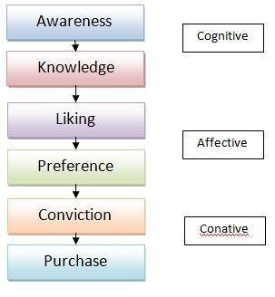

*Identify the relevant variable/s available under the four segmentation bases discussed above to segment the market for the following products and discuss why:*



6.2

1. *Clothes*
2. *Commercial Bank*
3. *Mobile phones*
4. *Flowers*
5. *Large retail stores*
6. *Tourist hotel*
7. *Political Party*

### 6.1.2 Requirements for Effective Segmentation

Though there are many ways to segment a market, all the segmentations are not effective for a particular product.

To be effective, the segments should fulfil the following characteristics.

#### Figure 6.4 Requirement for Effectiveness Segmentation

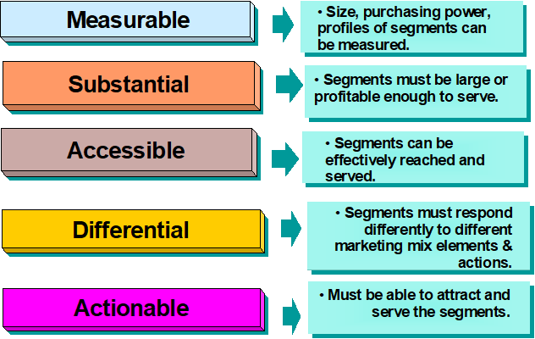

### 6.2 Market Targeting

Market targeting is the act of selecting one or more segments to enter. Here the company has to evaluate the various segments and select the appropriate segments to target

#### Thus, targeting involves two tasks

Evaluating attractiveness of each segment

Deciding how many and what segments to target

##### 1. Evaluating the Segments

To identify the attractive segments to enter, the company must evaluate each segment using

Segment size and growth

Structural attractiveness of the segments

Company objectives and resources

#### Segment size and Growth

In analysing the segments, first the company should consider whether the potential segment have the right size and growth characteristics

#### Structural Attractiveness

Here the marketer is concerning about the long-term profitability of the segment. The long run profit attractiveness of a segment can be assessed by Michael Porter’s five forces model. There are,

Threat of Intense Segment Rivalry: A segment is unattractive if it already contains strong and aggressive competitors.

Threat of new entrants: A segment is unattractive if it is likely to attract new competitors.

Threat of substitute products: A segment is unattractive when there are actual or potential substitutes for the product.

Threat of growing bargaining power of buyers: A segment is unattractive if the buyers have strong bargaining power which leads to prices down, forcing to increase quality etc.

Threat of growing bargaining power of suppliers: A segment is unattractive if the suppliers show a strong bargaining power which leads to raise prices of supplies, reducing quality etc.

#### Company objectives and resources

In addition to the criteria discussed above, the company must further consider its own objectives and resources in relation to the segment. Sometimes some attractive segments might get less attention because it does not mesh with the company’s long run objectives. Further the company must consider whether the company has required skills and resources to succeed in the segment.

##### 2. Selecting the market segments (Market targeting)

After evaluation of market segments, `the company now must design which segments to enter which is called target market selection. Market targeting can be carried out at different levels as presented below:

## 6.2.1: Market Targeting Strategies/ Levels of Market Targeting

### Undifferentiated marketing

Using an undifferentiated marketing (or mass marketing) strategy, a firm might decide to ignore market segment differences and target the whole market with one offer. Such a strategy focuses on what is common in the needs of consumers rather than on what is different. The company designs a product and a marketing program that will appeal to the largest number of buyers.

As noted earlier in the chapter, most modern marketers have strong doubts about this strategy.

### Differentiated Marketing (Segmented Marketing)

Using a differentiated marketing (or segmented marketing) strategy, a firm decides to target several market segments and designs separate offers for each.

### Concentrated (Niche) Marketing

A niche is a more narrowly defined group that may show a special combination of benefits. Simply, a group of customers whose needs are very specific. In this strategy, companies are trying to gain a larger share of a narrowly defined market rather than a smaller share of a larger segment (as may be practiced under differentiated marketing).

### Characteristics of niche

Customers seek special combination of benefits

Competition in the market is low than in the competition of gross segments

Marketer can presumably understand the need of niche so that they can satisfy them in a superior manner.

Customers are willing to pay a premium price

### Micro marketing (Local or Individual marketing)

Micro marketing is the practice of tailoring products and marketing programs to suit the tastes of specific individuals and local customer segments. Micromarketing is practiced at two different levels:

### Local Marketing

A micro market is a geographically based group of customers who have their own distinctive requirements.

### Individual Marketing (Customization)

Here, each customer is served differently with customer tailored marketing offers. This is also known as individual marketing one-to-one marketing, mass customization,



6.3

*Identify organizations/ products that seem to practice different level of targeting.*

## 6.3 Positioning the Marketing Offer

After selecting a target market to enter, next the company must think of how to differentiate and positioning its marketing offer in relation to its competitors. The company will be in a better position to earn high profits unless there are competitors serving the same target market. However, if there is another strong competitor or are several competitors in that segment, the company has to offer something different and of higher value to customers to attract customers to the company’s offer. This is achieved by differentiation and positioning the marketing offer.

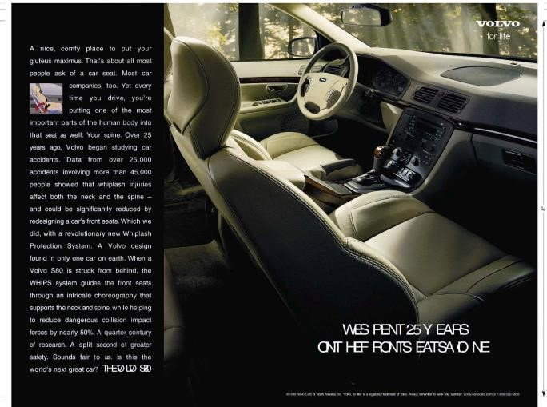

Positioning is the act of designing the company’s offer and image so that it occupies *a distinct and valued place in the target customers’ mind. (Kotler)*

Positioning a brand calls for ‘a three-steps’ process.

* Identifying possible differences/competitive advantages for the product/brand
* Choosing right differences to promote
* Communicating and delivering chosen competitive advantages to target customers

Each step is illustrated below.

### 6.3.1. Identifying possible differences/competitive advantages

The first step of positioning a brand is to identify all the possible ways that can differentiate the brand from the competitors. Accordingly, a company can differentiate its marketing offer along five broader areas as follows.

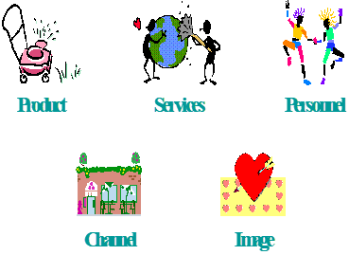

o Product differentiation o Service differentiation o Personnel differentiation o Channel differentiation o Image differentiation

#### Product Differentiation

The company can think of bases for differentiating its physical product first. Here, a number of product differentiators in terms of quality, features, performance, durability, reliability, style and design can be identified.

#### Service Differentiation

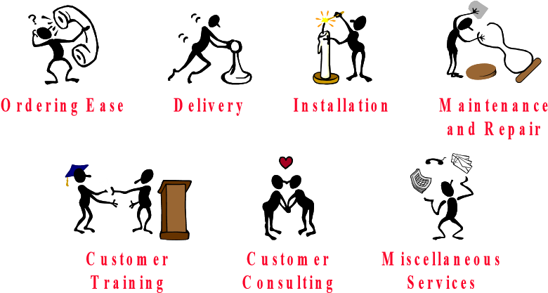The second option for a company to differentiate its product is the service differentiation i.e. providing more value to customer through the accompanying services e.g. after sales services. It is obvious that when the marketer finds it difficult differentiate the physical product, the competitive advantage often lies in service differentiation



6.4

*Identify with examples, the ways that a company can use to differentiate the service component to offer a superior value to its target customers.*

#### Personnel Differentiation

Companies can obtain a superior competitive edge by differentiating their people (personnel). This can be achieved by hiring capable people, training them and motivating them to offer excellent customer experience than competitors do. When customers interact with the staff, they clearly see a difference in terms of a variety of good qualities, which are not available with the staff at compactors places.

*When a product/service aims to deliver a better value though personnel differentiation, the staff should display several good qualities/characteristics to the customers. Identify such good qualities and relate them with your personal experiences that you have witnessed at various*



6.5

*places.*

#### Channel Differentiation

Companies now a days are trying to gain a competitive advantage through offering innovative and convenient channel options for customers to place orders, obtain information, purchase products, make payments, and lodge complaints. The purpose is to make the entire consumption experience is more convenient for customers than that of competitors.

*1.Select a commercial bank of your choice and identify all the channels used by the bank to serve its customers. Which channels do you think more convenient to carry out your financial activates and why?*



6.6

*2. Provide examples that some companies creatively used channel differentiation during the COVID19 pandemic.*

#### Image Differentiation

Though customers do not perceive any difference in the areas discussed before, if company can create a different image to the company and brand, it will gain a valuable competitive advantage. However, a different brand personality will not come to the product or company by itself. A creative and hardworking identity building effort (program) is needed to achieve this. Various tools are used for this purpose such as names, symbols, atmospheres, and events. The ultimate result of such a program is creating a strong corporate/brand Image. Companies take managerial efforts to develop a desired identity which eventually results in formation of an image in consumers’ mind.

**Identity**: This is the ways that the company aims to identify itself and its brands by publics.

**Image:** The way that public perceives the Company and

brands.

Creativity and effective communication is must to build a strong image. The image has to be conveyed through every possible communication vehicles and disseminated continuously. The message must be expressed in symbols, written and audio/visual media, atmosphere and events.

### 6.3.2 Choosing Right Competitive Advantages

All above ways of differentiators may not be meaningful or worthwhile for a brand as each difference tends to create costs to the company as well as benefits to the customers. Therefore, choosing right competitive advantages among the options identified is crucial for developing a strong value proposition for a product. This requires making decisions on two key aspects:

1. How many differences to promote?
2. Which differences to promote?

**How many differences to promote?**

In answering the above question, one prevalent way is to promote ‘one benefit’ to the target market known as *single benefit positioning*. If a company uses the single benefit positioning strategy, the benefit will act as *the unique selling proposition* (USP) of the brand. It is commonly believed that the brand must be positioned as the number one on that single benefit. Nevertheless, some companies are trying *double- benefit positioning*. For example, when another competitor also claims the same benefit, the company may think of the double-benefit positioning. Sometimes companies may decide to use triple or multi benefit positioning but promoting many differences to a brand may confuse the customers and crate doubts about the performance of the brand in consumers’ mind.

**Which differences to promote?**

Company should select the effective differentiators which are distinctive and valued by customers. For instance, if a company decides to promote two benefits to the brand, the selection of the two benefits/differences should be a sensible decision from both customers’ as well as the company’s perspectives. Hence, the following criteria are used by managers to assist that decision:

|  |  |
| --- | --- |
| **Consumer Desirability Criteria** | **Deliverability Criteria** |
| * Relevance: the benefit should be important to target customers. * Distinctiveness: the benefit can offer a substantial difference to target customers than the other brands. * Believability: customer should believe that the brand truly delivers the promised benefit. | * Feasibility: the company should have the requires capabilities to deliver the promised benefit. * Communicability: the benefit should be communicable and visible to customers. * Sustainability: with the promised benefit, the brand can hold a competitive advantage over competitors for a |

considerable time period.

Once a company come to a final decision regarding the above two elements i.e. how many and which differences to promote, the outcome is the **value proposition** of the brand. In a simple language, that is the promise of the brand to the target customers which highlights how the brand can satisfy customer’s needs and how it outperforms competitors’ brands.

#### 6.3.3. Communication and Delivering the Chosen Difference/s

Developing a clear and valued positioning strategy is not adequate at all. The marketing mix should be designed accordingly to offer what was promised to customers in the positioning strategy and the positioning strategy must be effectively communicated.

#### 6.3.4 Positioning Statement

A statement that summarizes company or brand positioning using the formula:

To [target audience], [product/service/organization name] is the only [category or frame of reference] that [points of differentiation/benefits delivered] because [reasons to believe]

#### 6.3.5. Positioning Maps

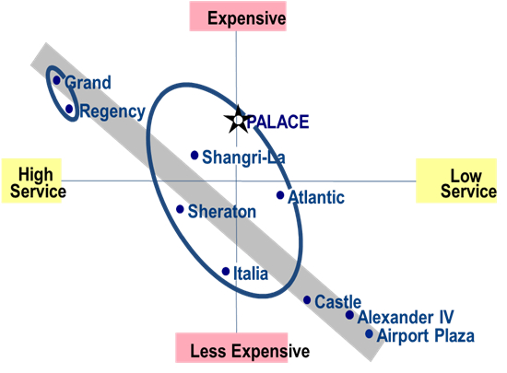In most cases, visual explanations are clearer and more appealing than the verbal or written statements. As such, positioning maps are often employed to better communicate about the value proposition of the brand while making comparisons with the competitive brands. In other words, positioning maps depicts consumer perceptions of a brands versus competing products on important buying dimensions. Following is an example of a positioning map which illustrates value perceptions of a set of competitive hotels on two important **Figure 6.5 Positioning Map** attributes i.e. level of service and price.

#### 6.3.6. Developing a Positioning Statement

A firm’s positioning strategy should be presented in summarised form called “positioning statement”. The statement generally follows the form: To (target segment and need) our (brand) is (concept) that (point of difference). For example, Nike’s Positioning statement is given below, and it seems to meet some of the criteria mentioned above:

*“At Nike, we're committed to creating a better, more sustainable future for our people, planet, and communities through the power of sport.”*

*The growing competition in the current financial industry in Sri Lanka demands financial institutions including the commercial banks to penetrate more markets and find new ways of adding values to their customers. XYZ is a reliable state bank with a well experienced and professional staff. In addition, the bank has more customer-oriented microfinance solutions than competitors. However, the bank has failed to capitalize such competitive advantages to position in the microfinance sector yet. XYZ bank is also aware that there are five leading players including some private-owned finance companies, earning substantial profits with their existing microfinance solutions. Having identified this as a promising opportunity, XYZ is aiming to further penetrate the microfinance sector by focusing more on ‘service conscious customers. Based on the above scenario,*



6.7

1. *Identify suitable segments XYZ bank can identify and suggest a suitable segment to target.*
2. *Identify three (03) possible ‘competitive differences’ for XYZ bank and evaluate the usefulness of proposed differences.*

*ii. Draw a positioning map to display the position of the XYZ bank in comparison with other finance institutes operating in the microfinance sector.*

iv. *Develop a suitable positioning statement for the microfinance solutions of XYZ bank*

An easily identifiable demographic group which is often targeted by marketers is college university. Do you think this is influenced more by a common economic status of the target group, geographic concentration of a specific age group, or some other



***Think***

***Deep***



factor (s)?

# Products, Services and Brands: Building Customer Value



## Chapter Overview

In many ways, this chapter provides the information required to truly understand marketing. It focuses on the definition of what products and services are, and it provides details about branding. After defining what a product is, the chapter goes on to detail the necessary attributes of products and services, as well as the branding, packaging, labelling, and product support decisions that marketers must make. There is information regarding product line and product mix decisions, and how to effectively manage both.

## Learning Outcomes

At the end of this chapter, students should be able to:

* Understand the meaning of product and its’ the characteristics
* Describe how a company builds and manages its product mix and product lines?
* Explain how a company makes better brand decisions?
* Explain how packaging and labelling be used as marketing tools?

### 7.1 Introduction

‘Product’ is a fundamental marketing concept and an integral component of marketing theory. Organisations offer various kinds of products for their markets with an objective of obtaining an adequate level of demand for them. Sales of such products generate an income flow for organisations to cover their operational and marketing costs and to achieve profit and other financial objectives. Thus, the survival and growth of an organisation is largely dependent upon the fact that whether they are able to offer right products to their customers in a competitive marketing environment. Customers possess the privilege of freedom to choose products from any competitive firm, locally or globally, in the modern marketing environment implying that marketers need to design and offer the best possible solutions for their customers to win the competition. This chapter therefore discusses the major product related concepts and decisions that marketing companies need to know and put into the practice. The topics include defining products, scope of products, classification of products, different levels of a product and product mix related decisions, branding and packaging.

**7.2. What is a Product?**



***“****A product is anything that can be offered to a market for attention, acquisition, use or consumption that might satisfy a want or need” (Philip Kotler)*

Think about some of your basic needs such as hunger and thirst and how you usually fulfil such needs. Probably an array of products would come to your mind, for example, if you think of hunger, you will remember various food products that can satisfy your need. Similarly, if you want to travel from one place to another, you may consider various transport alternatives such as busses, trains, taxies and personal vehicles etc.

These examples imply that people have many options in terms of variety of goods and services to fulfil their needs. Such goods and services are called ‘products’ in a broader term. Hence, products are primarily designed for fulfilling needs and wants of people. Accordingly, we can define a product as *anything that can satisfy a human need or want*.

We also need to understand that people try to fulfil different levels of needs (e.g. physical needs, social needs, security needs) through products thus marketers need to offer right products for satisfying such different needs. For example, food and clothing products for physical needs, insurance and medical products for security needs and mobile phones and tour packages for social needs etc. We most often think of products as physical objects. However, marketers are also concerned with promoting service- oriented products such as insurance, banking, and movies. Products also include experiences, events, persons, places, properties, organisations, information and ideas.

**7.3. Product Levels:**

When a product is offered to a market, the marketer should think through mainly five product levels. (Refer Figure 7.1)

#### Figure 7.1 Product Levels

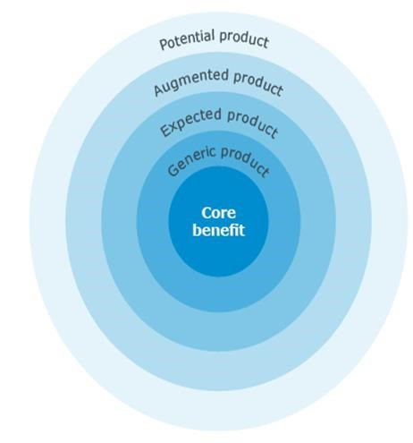

**Core benefit:** The fundamental need or want that consumers satisfy by consuming the product or service. For example, the need to process digital images.

**Generic product:** A version of the product containing only those attributes or characteristics absolutely necessary for performing its main function. For example, the need to process digital images could be satisfied by a generic, low-end, personal computer using free image processing software or a processing laboratory.

**Expected product:** The set of attributes or characteristics that buyers normally expect and agree to when they purchase a product. For example, the computer is specified to deliver fast image processing and has a high-resolution, accurate colour screen.

**Augmented product:** The inclusion of additional features, benefits, attributes or related services that serve to differentiate the product from its competitors. For example, the computer comes preloaded with a high-end image processing software for no extra cost or at a deeply discounted, incremental cost.

**Potential product:** This includes all the augmentations and transformations a product might undergo in the future. To ensure future customer loyalty, a business must aim to surprise and delight customers in the future by continuing to augment products. For example, the customer receives ongoing image processing software upgrades with new and useful features.

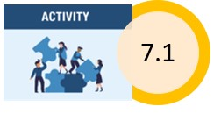 *Suggest better products (solutions) which have recently appeared and challenged the following products:*

*Fixed telephones*

*Movie theatres*

*Traditional postal service*

*Physical data storing cabinets and files*

*Physical shopping centres*

### 7.4. Product Classification

Products can be classified into three groups according to their durability or tangibility.

**Non-durable goods:**

These goods are tangible and used for one or a few user s. Non-durable consumer goods such as shampoo, full cream milk power is purchased frequently. This suggests that they should be made available in many locations and promoted with advertising to induce trial and to build preference.

**Durable goods:**

Durable goods are tangible goods that are normally used by many users. Durable goods last longer and are replaced less frequently. These products require more personal selling and services and also require more seller guarantees and command a higher profit margin. e. g. Refrigerator

**Services:**

Services are activities, benefits or satisfactions that are offered for sale. Services are:

Intangible – They cannot be seen, tasted, felt, heard or smelled before they are bought.

Inseparable- typically produced & consumed simultaneously.

Variable – Services depend on who provides them & when and where they are provided.

Perishable – Services cannot be stored.

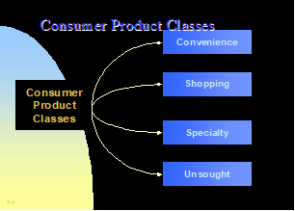**Consumer Products Classification:**

These goods can be classified on the basis of consumer shopping habits.

⮚ **Convenience products:** Convenience goods are purchased frequently, immediately and with a minimum of effort. Examples include soap, toothpaste and Newspapers. Convenience goods can be further classified into,

**Staple products**- Goods that consumers purchase on a regular basis. e.g., rice

**Impulse products**- Impulse goods are purchased without any planning or search effort.

These goods are usually displayed widely.

e.g., Candy bars are kept normally at the cashiers’ counter.

**Emergency products-** these goods are purchased because of an urgent need.

e.g., Umbrellas during a rainstorm.

⮚ **Shopping products:** In the process of selection and purchase of shopping goods, customers characteristically compare the goods on the bases such as suitability, quality, price and style.

⮚ **Specialty products:** These goods have unique characteristics and / or brand identification for which a significant group of buyers are habitually willing to make a special purchasing effort. e. g. computers

⮚ **Unsought products:** Goods that the consumer does not know about or knows about but does not normally think of buying.

e. g. New products – consumer does not know about the product

Life insurance – consumer knows about the product but does not normally think of buying.

### 7.5. Product Mix Decisions

**A product mix** (also called as product assortment) is the set of all product lines & items that a particular seller offers for its target markets. Product assortments are usually described in terms of width, length, depth and consistency.

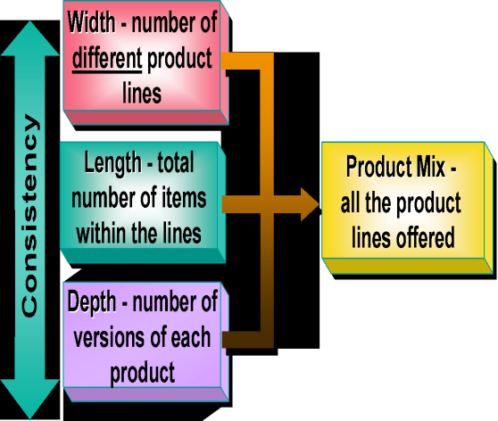**Width** refers to the number of different product lines that are marketed by a single firm.

**Length** refers to the number of items sold by a company within each product line (i. e. total number of items in its product mix).

**Depth** refers to how many variants are offered of each product item in the product lines.

**The consistency** refers to how closely relate the various product lines are in end use, production requirements, distribution channels or some other way.

These four dimensions of the product mix provide useful starting points for determining product mix strategies of a firm. Companies can use them to expand in three basic directions. First, they can add new product lines to serve a broader range of customers (widening its product mix). Second, they can deepen their model offering by adding product variations (deepening). Third, they can lengthen their product line and fourthly, the company can pursue more product-line consistency or less, depending upon whether it wants to acquire a strong reputation in a single field or participate in several fields.

### 7.6. Product-Line Decisions

*A product line is a group of products that are closely related because they perform a similar function, are sold to the same customer groups, are marketed through the same channels, or make up a particular price range. -(Philip Kotler)*

#### Product-Line analysis

Product line managers should know all the details of each item in their product line such as sales, profit and how the product line is positioned against competitors’ product lines to determine which items to build, maintain, harvest, or divest. Product line managers also need to understand the market profile of each product line.

**Product-Line length:** The best product mix strategy for a particular firm depends on the production, marketing skills available, financial resources and the objective of the organisation. Well-managed firms with limited product lines can often increase profits by expanding their product offerings. Mature organisations with extensive product assortments can make money by dropping items. By weeding out slow-selling products, costs can be reduced and profits increased.

A Company can enlarge the length of its product line in two ways by:

Line stretching

Line filling

**Line stretching decisions:** Line stretching occurs when a company lengthens its product line beyond its current range. The company can stretch its line downward, upward, or both ways.

**Line filling decisions:** A product line can also be lengthened by adding more items within the present range of the line. But the new product should have a noticeable difference and it should meet a market need.

**Line modernization:** Product lines need to be modernised periodically. In rapidly changing product markets, modernization is carried out on continuously. In doing so, marketers offer new styles, new sizes, new shapes etc to cope up with the new market requirements.

**Line-pruning:** On the basis of line analysis from time to time, management has to cut down some items of the line which have poor performance.

*Liyara Products (Pvt.) Ltd. is a well-known confectionary*  *manufacturer in Sri Lanka. At present, they are manufacturing*

*four (04) brands of biscuits, three (03) brands of chocolates*

*and five (03) brands of cakes. They offer three (03) sizes from*

*Liyara Cracker biscuit packs and three (03) flavours from*

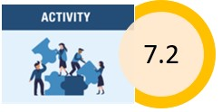*Liyara Creamy Chocolate. Also, Liyara Products has introduced two (02) sizes in its all-cake brands at prices of Rs. 150/= and Rs. 300/=.*

*Draw the product mix of Liyara Products (Pvt.) Ltd, and comment on width, length, depth, and consistency of the*

*product mix.*

## 7.7. Branding

Branding decisions are one of the major decisions to be taken in the product strategy. Branding a product requires a great deal of management effort since it is a long-term investment.

### How to define a brand,

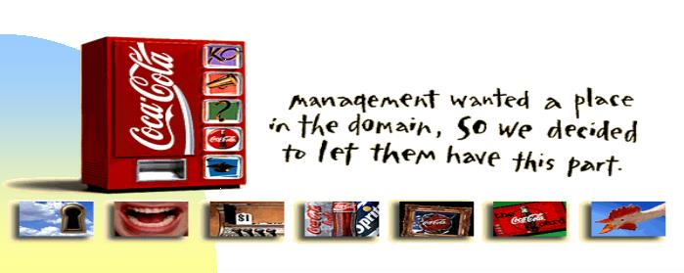*A brand is a name, term, sign, symbols*  *or design, or a combination of them, intended to identify the goals or services of one seller or group of sellers and to differentiate them from those of competitors. (The American Marketing Association)*

Marketers use names, trademarks, logos and other symbols as brands. According to trademark law the seller/maker is granted exclusive right to the use of the brand name in perpetuity. Brands do not have expiration dates like patents and copyrights. Brand name has a narrow meaning. A brand name is a word, letter, or a group of words or letters. Trademark is a legal term. A trademark includes only those words, symbols or marks that the law says are trademarks. Brands create a set of expectations in the minds of customers about purpose, performance, quality, and price. This will allow a marketer to build added- value into products and to differentiate them from competition.

By developing a brand, a seller is committed to deliver a specific set of features, benefits and services consistently to the consumers. On the other hand, a brand helps consumers to identify the seller/maker.

The best brand conveys a warranty of quality. Further it can convey other six levels of meanings. They are;

**Attributes**: A brand carries certain attributes of a product. Brand of Mercedes conveys expensive, well-built, well-engineered, durable, high prestige automobiles.

**Benefits:** The attributes are brought by the brand must be translated into functional reality and emotional benefits. The attributes "durable" could be translated into long-term usage of the product as functional reality. Whereas attributes "expensive" could be translated into the emotional benefits of feel important and admired.

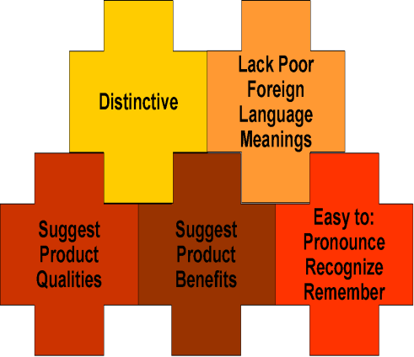**Values:** The brand should convey the messages about the producer's values. Mercedes stands for high performance, safety and prestige.

**Culture**: A brand may represent a certain culture.

The Mercedes represents German culture; Organized, efficient, high quality.

**Personality**: A brand can be used to represent a certain personality.

**User**: A brand can be used to suggest the kind of consumer who buys or uses the product. The brand Mercedes may suggest the user as 55-year-old top executive.

Brands should not be developed to communicate only attributes of products for several reasons. First buyers are not as interested in attributes as in benefits. Second competitors can easily copy attributes. Third, the current attributes may be less desirable later.

Marketers should prevent promoting the brand only on benefits too. Once the marketer promotes his brand on one benefit at a level, competition may come up with another brand on more benefits than the company. Further consumers may vary benefits. Marketers should always keep the freedom in to a new benefit positioning.

### 7.8. Branding Decisions

Following figure 7.2 shows the key branding decisions to be taken by the marketer.

#### Figure 7.2 Branding Decisions

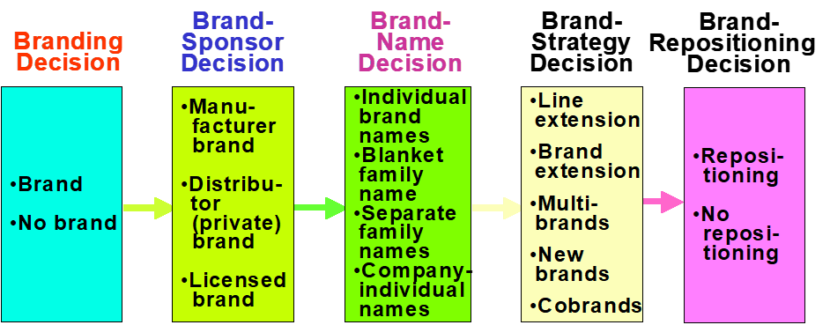

### Branding Decisions - To brand or not to brand

First the company should decide whether they want to develop a brand name for its products. Earlier companies did not involve in branding. But later branding became very important to put trademarks on their products to protect themselves and consumers against inferior quality.

Branding creates several costs to the company while bringing several advantages.

Brand name and trademark provides legal protection for companies' products.

Branding gives marketer the opportunity to attract loyal and profitable set of customers. This brand loyalty can be used to face the competition in the markets.

Instead of depending on one market, companies use branding to divide the market into several segments.

Strong brands help the company to build the corporate image. The corporate image makes it easy to launch new brands and gain acceptance by distributors and consumers.

Distributors and other intermediaries require brand names because it will make the product easier to handle, maintain production to certain quality standards, and strengthen buyer preferences and identifying suppliers. On the other hand, customers seek for brand names to identify quality differences and to shop efficiently.

#### Brand - Sponsor Decisions

There are many alternatives available under brand sponsor decisions. The products can be branded as a Manufacturer’s Brand (National Brand), a Distributor’s Brand (Reseller, Store, House or Private Label Brand), or a licensed Brand. Although manufacturer's brands are dominant, large retailers and wholesalers have been developing their own brands by contracting the production with agreed manufacturers. These Private Label Brands offer two advantages. First, they are more profitable. Manufacturers with excess capacity will produce private labels at a low cost. Other costs, such as research and developments, advertising, sales promotions, and physical distribution are also much lower. Under these circumstances private branders can charge a low price and it will make a higher profit margin. Second, middlemen develop exclusive store brands that will differentiate themselves from those of competitors. One of the disadvantages for the national brands is many consumers do not distinguish national brands from store brands.

#### Brand Name Decision

There are four strategies that marketers can use to select a brand name to a product.

**Individual Names:** Establishing an individual name for a product. In this strategy, the company does not connect its reputation to the product. The advantage of establishing individual name is that the product fails or appears to have low quality, the company’s name or image would not hurt.

e.g., Unilever establishes individual brand names for all its products such as Lux, Rexona etc.

The strategy allows the company to use a new name for each new product.

**Blanket Family Names:** Under this strategy, marketers do not necessarily take any extra effort to create brand name recognition. Reduction of heavy advertising expenditure is an advantage of this strategy. In case, the manufacture has a good brand name, sales of new products are also likely to be high.

1. g., Johnson & Johnson introduces its products always under the same brand name.

**Separate Family Names for all Products:** There are some companies that produces quite different products and do not use one blanket family name, turn to use separate family names for the products. e.g., Softlogic

**Company Trade Name combined with Individual Product Names:** Companies those who follow this strategy tie their company name to an individual brand name for each product. The company name legitimizes, and the individual name individualizes the new product.

e.g. Anchor full cream milk powder, Anchor Pediapro

When marketers select its brand name strategy, they should select a specific brand name. The brand name can be a name of a person, location, quality, lifestyle, or an artificial name.

#### Qualities of a good Brand Name

* It should suggest something about the product's benefits. E.g., '' Samaposha"
* It should suggest product qualities such as action or colour. E.g., "Pearl white" laundry soap.
* It should be easy to pronounce, recognize and remember. E.g., " Rin"
* It should be distinctive. E.g., " Kodak: Fuji Films"
* It should not carry poor meaning in other countries and languages. E.g., " Nova" in Spanish-

Speaking Countries. It means "doesn't go”. “Chick" in Sinhala speaking countries .It means "doesn't pretty.

Before coming to the final decision about a brand name of a product a company should create a list of possible names. The list should be put into debates. Also, the list of names should be tested with target customers.

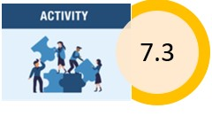 *Identify examples of brand names that have been developed using:*

▪ *Name of person*

▪ *Name of locations*

▪ *Name of animals*

▪ *Name implying a quality or benefit of the product* ▪ *Artificial names*

### Brand Strategy Decisions

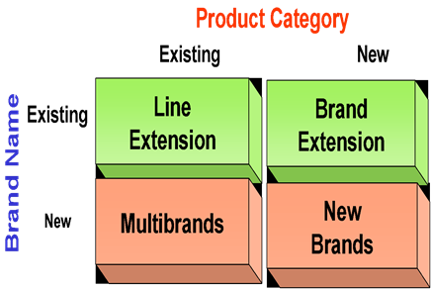There are five brand strategies available for marketers to take brand strategic decisions.

**Line Extensions:** Company takes its existing product category and under existing brand name they introduce new sizes, flavours, forms, colours, added ingredients, package sizes of the same product category.

**Brand Extensions:** Under this strategy brand names are extended to other new product categories. "Honda" uses its company name to cover such different products as automobiles, motorcycles, snowblowers, lawn mowers, main engines and snowmobiles. Like line extension, brand extension also involves risks. The new product might not satisfy existing customers and that would hurt their reputations for the company's other products. Sometimes the existing brand may not be appropriate to the new product. The existing brand name may lose its special positioning in the consumer's mind through over extension.

**Multi Brands:** Under this strategy new brand names are introduced under the same product category. The Multi branding strategy enables the company to entertain more distributors selfspace and to protect its major brand by setting up flanker brands. The strategy can be also applied to acquire competitors.

**New Brands:** Create a new brand name for a new product category. Marketers can apply this strategy for a company that finds that none of its current brand names are appropriate for its products in a new category. According to the strategy a company creates a new brand name for new category products.

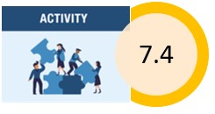 *Identify relevant and suitable examples for different branding strategies*

### Co-brands

Establishing brands bearing two or more well-known brand names. The strategy is also called dual branding. Each brand sponsor expects that the other brand name will strengthen preference or purchase intentions.

### Brand Repositioning

Once a brand is developed for a product it should be positioned in a market well. However due to new competition or changing customer preference the company may have to reposition the brand.

e.g., "7 up'' non-cola drink was introduced to the market targeting older people who wanted a blank, lemon- flavoured drink. Finally, a research indicated that although the majority of soft drink consumers preferred a cola, they did not prefer it all the time and many other consumers were non cola drinkers. Again another "7 up " campaign was conducted to feature the non-cola as a youthful and refreshing drink. “7 up" established itself as the alternative to colas, not just another soft drink.

## 7.9. Packaging and Labelling

Many marketers identify packaging as the fifth "P" along with price, product, place and promotion. However, some marketers identify that packaging and labelling as an element of product strategy.

### Packaging

Activities of designing and producing the container for a product is called packaging.

The container is called as the package, which might consist up to three levels of materials such primary packaging, secondary packaging and shipping packaging.

Well-developed packages give convenience and promotional value to a company. Factors like selfservice, consumer affluence, company and brand image, and innovation opportunities contributed to growing packaging as an important marketing tool.

Developing effective packaging for a new product marketer must take several decisions.

First marketers should have an idea on what they expect to package. This packaging concept leads to several other decisions. Other decisions should be made on additional elements such as size, shape, materials, colour, text, and brand. All these packaging elements must also be in accordance with decisions on price, advertising, and other marketing elements.

Once the packaging is designed for a product it must be tested. Engineering test is conducted to test whether the packaging stands up under normal conditions. Visual tests ensure that the script is legible and the colours harmonious. Dealer tests are conducted to ensure that the dealer finds the package attractive and easy to handle. Marketers test whether the developed packaging has favourite consumer responses by conducting a consumer test. In developing a package for company's product, they also should concern about growing environmental and safety concerns about packaging

### Labelling

A label can be a simple tag attached to a product or an elaborately designed graphic that is a part of the packaging. Some labels carry only the brand name while other labels carry a great deal of information. Sometimes some legislation requires marketers to design labels to carry additional information.

1. 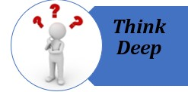Pick two product categories – one should be a physical good and the other should be a service. For each product that you have selected, outline how the five product levels could be structured.

1. In your view, how helpful is it for a marketer to split the product into its different product levels?

1. Do you think that the five-level product model has any extra

value to a marketer, as compared to the three-level product

model?



**Pricing: Understanding**

**and Capturing Customer**

**Value**

### Chapter Overview

Chapter four focuses on explaining the second major marketing mix tool, pricing. Firms that are successful in creating customer value with other marketing mix activities still have to capture some of this value in the prices they earn. First this chapter discusses the importance of pricing and internal and external considerations. Then, the chapter elaborates pricing process. Finally, the chapter discusses on major pricing strategies, new product pricing strategies and price adaptation strategies. Finally it focuses on initiating and responding to price changes.

### Learning Outcomes

At the end of this chapter, students should be able to:

* Define price and explain importance of it in marketing mix.
* Identify the major considerations in price setting.
* Identify Internal and External considerations affecting price decisions.
* Contrast three approaches to setting prices.
* Describe major strategies for pricing new products.
* Discuss how adopting the price and responding to price changes.

**8.1. What is Pricing?**

Price is not just a number on a tag. It comes in many forms and performs many functions. Rent, tuition, fares, fees, rates, tolls, retainers, wages, and commissions are all the price you pay for some good or service. In the narrowest sense, price is the amount of money charged for a product or a service. More broadly, price is the sum of all the values that customers give up to gain the benefits of having or using a product or service.

#### Definition of Price

*Amount of money charged for a product or service or the sum of values consumers exchange for the benefits of having or using the product or service*

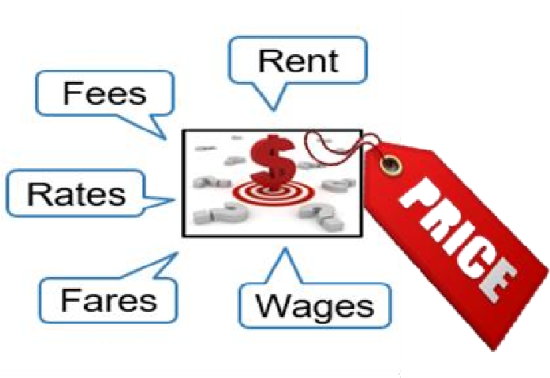

During the early days of marketing, price was the major determinant of buyer’s choice. This is still true for less affluent customers and groups in the world. However, non-price factors have become relatively more important in buyer-choice behaviour in recent years. Yet price still plays a key role in determining company market share and profitability.

Price is the only element in the marketing mix that generates revenue, with all other elements in the marketing mix; product, promotion and location, representing costs. Price is also one of the most flexible elements of the marketing mix. In contrast to product features and channel commitments, prices can be changed quickly. In addition, prices have a direct impact on a firm’s bottom line. A small percentage improvement in price can generate a large percentage increase in profitability. More importantly, as part of a company’s overall value proposition, price plays a key role in creating customer value and building customer relationships.

#### 8.2. Internal and External Considerations Affecting Price Decisions

The price the company charges will fall somewhere between one that is too high to produce any demand and one that is too low to produce a profit. Figure 8.4 summarizes the major considerations in setting prices. Customer perception of the product’s or service’s value set the celling for its price. If consumer perceived that the product’s price is greater that the value, they will not buy the product. Likewise, product costs set the floor for a product’s price. If the company prices the product below its costs, the company profit will suffer. Between the two extremes, the “right" pricing strategy is one that delivers both value to the customer and profits to the company.

In setting its price between these two extremes, the company must consider several internal and external factors, including competitors’ strategies and prices, the overall marketing strategy and mix, and the nature of the market and demand. Internal factors affecting pricing include the company’s overall marketing strategy, objectives, and marketing mix, as well as other organizational considerations. External factors include the nature of the market and demand and other environmental factors.

##### Figure 8.1: Considerations in Setting Price

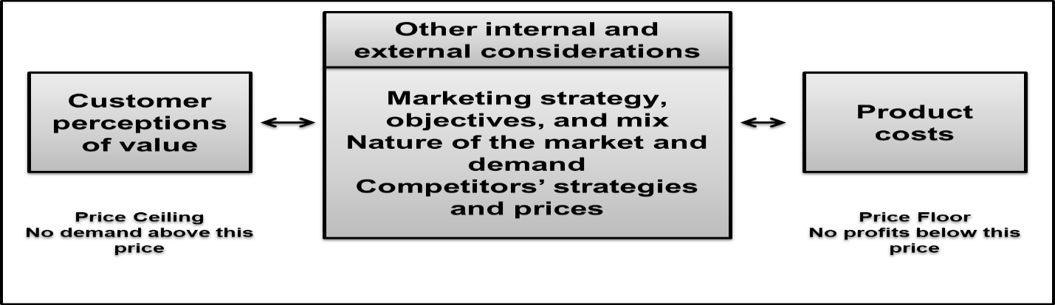

###### 8.2.1. Overall Marketing Strategy, Objectives, and Mix

Price is only one element of the company’s broader marketing strategy. Thus, before setting price, the company must decide on its overall marketing strategy for the product or service. For example, when Honda developed its Acura brand to compete with European luxury-performance cars in the higher income segment, this required charging a high price. In contrast, when it introduced the Honda Fit model this positioning required charging a low price. Thus, pricing strategy is largely determined by decisions on market positioning. Pricing may play an important role in helping to accomplish company objectives at many levels. A firm can set prices to attract new customers or profitably retain existing ones, to prevent competition from entering the market or set prices at competitors’ levels, to stabilize the market and to keep the loyalty and support of resellers, to avoid government intervention and event to create excitement for a brand. Decisions made for other marketing mix variables may affect pricing decisions. Therefore, price decisions must be coordinated with product design, distribution, and promotion decisions to form a consistent and effective integrated marketing program.

###### 8.2.2. Organizational Considerations

Management must decide who within the organization should set prices. Companies handle pricing in a variety of ways. In small companies, prices are often set by top management rather than by the marketing or sales departments. In large companies, pricing is typically handled by divisional or product line managers.

###### 8.2.3. The Market and Demand

Before setting prices, the marketer must understand the relationship between price and demand for the product of the company, because the freedom of pricing of the seller varies between different types of markets and the price elasticity of demand.

###### 8.2.4. The Economy

Economic conditions can have a strong impact on the firm’s pricing strategies. Economic factors such as a boom or recession, inflation, and interest rates affect pricing decisions because they affect consumer spending, consumer perceptions of the product’s price and value, and the company’s costs of producing and selling a product.

###### 8.2.5. Other External Factors

The company must consider several other variables in its external environment when setting prices, such as resellers, government and social concerns.

"*Best-tech" is an educational institution that offers digital marketing courses in both online and offline modes. Identify internal and external factors to be considered when determining the price(s) of the course.*



8.1

#### 8.3. Pricing process

The firm must consider many factors in setting its pricing policy. Figure 8.2 summarizes the six steps in the process.

**Figure**

**8.2**

**Pricing Process**

1

•

Selecting pricing objectives/goal

2

•

Determining Demand

3

•

Estimating Costs

4

•

Analyzing competitors’ costs, prices and offers

5

•

Selecting a pricing Method

6

•

Selecting the Final Price

##### 8.3.1. Step 01: Selecting pricing objectives/goals

First, the company decides where it wants to position its market offering. The clearer the objectives of a company, the simpler it is to set price. A company can select any of the five objectives: Survival, Current Profit Maximization, Market Share Maximization, Maximum Market Skimming, Quality Leadership. Non-profit and public organizations may have other pricing objectives such partial or full cost recovery.

##### 8.3.2. Step 02: Determining Demand

Demand is a relationship between two economic variables; the price of a particular good, and the quantity of the goods consumers are willing to buy at that price during a specific time period, all other things being equal. The normally inverse relationship between price and demand is captured in a demand curve. The higher the price, the lower the demand. Further, the demand curve shows the market’s probable purchase quantity at alternative prices, summing the reactions of many individuals with different price sensitivities.

The first step in estimating demand is to understand what affects price sensitivity. Generally, customers are less price sensitive to low-cost items or items they buy infrequently. They are also less price sensitive when (1) there are few or no substitutes or competitors; (2) they do not readily notice the higher price; (3) they are slow to change their buying habits; (4) they think the higher prices are justified; and (5) price is only a small part of the total cost of obtaining, operating, and servicing the product over its lifetime.

The firm should then estimate the demand curve; a graph of demand showing the relationship between price and quantity demanded. Most companies are trying to measure their demand curves using several different methods such as surveys, price experiments, statistical analysis. Finally, marketers need to know Price elasticity of demand; how responsive, or elastic, demand is to a change in price. Organization try to make their brand less elastic, allowing firm to charge higher prices. This can be done with advertising or by bundling your basic product or service with other products or services.

##### 8.3.3. Step 03: Estimating Costs

Demand sets a ceiling on the price the company can charge for its product. Costs set the floor. The company wants to charge a price that covers its cost of producing, distributing, and selling the product, including a fair return for its effort and risk.

Costs come in to two basic forms, Fixed or Variable. Fixed costs include expenditures for overhead such as plant, equipment, and executive salaries etc. which do not vary with the levels of output. Variable costs represent the direct labour, materials, and commissions needed to produce and sell each unit of merchandise and varies with production levels. Total costs are the sum of the fixed and variable costs at various levels of output.

Total Cost = Fixed Cost +Variable Cost

At this stage, Firm should not only estimate total costs but also how their costs vary at different levels of output, at different levels of accumulated production experience and for differentiated marketing offerings.

##### 8.3.4. Step 04: Analyzing competitors’ costs, prices and offers

The company must have a thorough knowledge about their product quality & competitor price levels. If the firms’ product quality is as same as competitors’ product quality, company can set a price close to the competitors’ price. But, in the case of superior or inferior to competitor, company must have their own strategies to set the final price.

##### 8.3.5. Step 05: Selecting a pricing method

There are many price-setting methods: markup pricing, target-return pricing, perceived-value pricing, value pricing, going-rate pricing, and auction-type pricing.

##### Mark-Up Pricing/Cost Plus Pricing

Most of time marketers will add a standard profit margin to its total production cost.

Example.

Variable cost per unit is Rs.10 , Fixed cost is Rs.300,000 and Expected unit sales are Rs.50,000

##### Unit cost = Variable Cost + Fixed Cost Expected Unit Sales

|  |  |
| --- | --- |
| = | (10*50000) + 300000 |
|  | 50000 |
| = | Rs.16 |

Assuming that manufacturer want 20% Mark-up on sales (25 % on the cost) Cost Plus price = Unit Cost + (Unit Cost * 25%) = Rs. 20

Mark-up Price = Unit Cost = Rs.16 = Rs.20

(1-desired return on sales) (1-0.2)

##### Target - Return Pricing

In this method, company determining their product price based on their target rate of return on investment (ROI)

Eg;

|  |  |
| --- | --- |
| Fixed Cost | Rs. 300,000 |
| Unit Cost | Rs.16 |
| Desired Return | 20% |
| Invested Capital | Rs. 1,000,000 |
| Expected Unit Sales | 50,000 |
| **Target Return Price** | **= Unit Cost + (desired return x invested capital)** |
|  | **Unit Sales** |

= Rs.16 + (.20 x Rs.1,000,000)

50,000

= Rs.20

Manufacturer can find the breakeven volume to recover their fixed cost as follows.

Breakeven Volume = Fixed Cost = Rs.300,000 = 30,000 units (Price – Variable Cost) (Rs.20 – Rs.10)

##### Perceived Value Pricing

Increasing number of firms use this method, which focus on buyers’ perception of value, rather than sellers’ cost of production. They may use other marketing elements to build a strong perception about the product in consumers’ mind.

##### Value Pricing

Some companies have adopted value pricing; in which they charge a fairly low price for a highquality offering. Value pricing says that the price should represent a high value offer to consumers**.**

##### Going Rate Pricing

Company will set their prices mainly upon the prices of competitors. To do so, company must have through knowledge about their competitors.

##### Sealed Bid Pricing

The firm bases its prices on expectations of how competitors will price rather than on a rigid relation to the firms’ costs or demand.

###### 8.3.6. Step 06: Selecting the Final Price

Before set in final price to the product, the firm must consider additional factors such as;

* Psychological Pricing
* The influence of other marketing mix elements
* Company Pricing policies
* Impact of price on other parties

##### Psychological Pricing

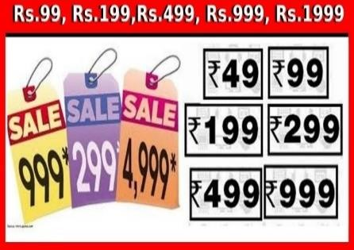Most of the consumers use prices as a mirror of the price quality. Thereby, marketers use their prices to have a psychological effect on the consumers. Mainly ego-sensitive products like perfumes and expensive cars will have a high impact on their prices. But, when alternative information about true quality is available, price become a less significant indicator of quality. “Reference Price” is also major influencer for the consumers. Some sellers may situate their products among very expensive products to imply that it belongs in the same class.

Also, sometimes sellers will set their prices by using an odd number. As an example, Bata shoe company will set their prices as Rs.299.99 rather Rs300, which imply to the consumers within Rs 200 range rather than in reality of Rs300 range.

##### The influence of other marketing mix elements

There are other marketing mix elements that may effect on the product prices, such as advertising, product quality.

**Company Pricing Policies**

Most of the companies set their pricing policies.

##### Impact of price on other parties

There are other factors that influence pricing. That is;

* Distributors & Dealer reactions
* Sales force attitudes
* Competitor reactions
* Supplier actions

#### 8.4. Major Pricing Strategies

There are three major pricing strategies: customer value-based pricing, cost-based pricing, and competition-based pricing.

##### 8.4.1. Customer value-based pricing

Customer value-based pricing is defined as setting price based on buyers’ perceptions of value rather than on the seller’s cost. Value-based pricing means that the marketer cannot design a product and marketing program and then set the price. Price is considered along with all other marketing mix variables before the marketing program is set. Therefore, in value-based pricing, the company first assesses customer needs and value perceptions. It then sets its target price based on customer perceptions of value.

The targeted value and price drive decisions about what costs can be incurred and the resulting product design. As a result, pricing begins with analysing consumer needs and value perceptions, and the price is set to match perceived value.

##### Figure 8.3: Value-based pricing

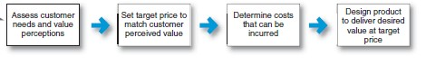

There are two types of value-based pricing: good-value pricing and value-added pricing.

**Good-value pricing** means offering the right combination of quality and good service at a fair price. In many cases, products are introduced at a fair price without minimizing product quality by using cost management techniques such as no frill products and services, economies of scale, experience curve, product design and production operations. For example, Ryannair offers low fares by eliminating non-essential services, such as complimentary food.

**Value-added pricing** is attaching value-added features and services to differentiate the company's offerings and charge higher prices rather than lower prices to match competitors. For example, Higher-priced premium airlines, such as Singapore Airlines and Emirates, provide customers with more value and charge higher prices. Value is added in terms of comfort, luxury, premium service and so on.

###### 8.4.2. Cost-Based Pricing

Whereas customer-value perceptions set the price ceiling, costs set the floor for the price that the company can charge. Cost-based pricing involves setting prices based on the costs for producing, distributing, and selling the product plus a fair rate of return for its effort and risk. A company’s costs may be an important element in its pricing strategy. Although costs are an important consideration in setting prices, cost-based pricing is often product driven.

The company designs what it considers to be a good product, adds up the costs of making the product, and sets a price that covers costs plus a target profit. Marketing must then convince buyers that the product’s value at that price justifies its purchase. If the price turns out to be too high, the company must settle for lower mark-ups or lower sales, both resulting in disappointing profits.

##### Figure 8.4: Cost based Pricing



###### 8.4.3. Competition-Based Pricing

Competition-based pricing involves setting prices based on competitors’ strategies, costs, prices, and market offerings. Consumers will base their judgments of a product’s value on the prices that competitors charge for similar products. In assessing competitors’ pricing strategies, the company should ask several questions. Such, how does the company’s market offering compare with competitors’ offerings in terms of customer value? Next, how strong are current competitors, and what are their current pricing strategies? What principle should guide decisions about what price to charge relative to those of competitors?

*During the Covid-19 pandemic, both leading and small players in the Sri Lankan retail industry have started to deliver consumer essentials to households through online and offline channels. Everything.lk which operates in Western province is*



8.2

*purely an online retail business started to capitalize this*

*emerging opportunity.*

*Suggest appropriate pricing strategy for Everything.lk with justifications*

#### 8.5. New-Product Pricing Strategies

Pricing strategies usually change as the product passes through its life cycle. The introductory stage is especially challenging. Companies bringing out a new product face the challenge of setting prices for the first time. They can choose between two broad strategies: market-skimming pricing and market-penetration pricing.

##### 8.5.1. Market-skimming pricing

Many companies that invent new products set high initial prices to “skim” revenues layer by layer from the market. Apple frequently uses this strategy, called market-skimming pricing (or price skimming). Market skimming makes sense only under certain conditions. First, the product’s quality and image must support its higher price, and enough buyers must want the product at that price. Second, the costs of producing a smaller volume cannot be so high that they cancel the advantage of charging more. Finally, competitors should not be able to enter the market easily and undercut the high price.

##### 8.5.2. Market-Penetration Pricing

Rather than setting a high initial price to skim off small but profitable market segments, some companies use market-penetration pricing. Companies set a low initial price to penetrate the market quickly and deeply—to attract a large number of buyers quickly and win a large market share. The high sales volume results in falling costs, allowing companies to cut their prices even further.

*Suggest product categories/products that would most likely fit the skimming pricing strategy? Discuss why?*



8.3

#### 8.6. Price Adjustment Strategies

Ones company has selected a basic price for goods & services, there are number of situations in which adjustments have to be made to account for unique market conditions.

**8.6.1. Geographical Pricing**

Geographical pricing reflects the strategies to its products’ prices in different locations & countries.

##### 8.6.2. Discounts & Allowances

Most companies adjust their basic price to reward customers for certain responses, such as the early payment of bills, volume purchases, and off-season buying. These price adjustments called discounts and allowances. Discount is defined as a straight reduction in price on purchases during a stated period of time or of larger quantities and allowance is defined as a Promotional money paid by manufacturers to retailers in return for an agreement to feature the manufacturer’s products in some way. There are different forms of discounts available as indicated below.

**Cash Discounts:** Most common discount is cash discount. It will reduce some amount from the bill to make incentive to pay the bills early. Cash discounts improve the cash flow for the seller and reduce collection costs. E.g.: Although payment is due within 45 days, the buyer can deduct 3% if the bill is paid within 10 days.

**Quantity Discounts:** A price reduction for buyers who purchase in large quantities. The objective of this discount is to get customers to increase order sizes and to buy from fewer suppliers.

**Trade/Functional Discounts:** This will offer by manufacturers to channel members for the motivation of selling, storing and record keeping.

**Seasonal Discounts:** This is a price reduction to buyers who merchandise or services out of season.

##### Allowances

Allowances for price reductions are designed to compensate buyers for certain activities. Promotional allowances, for example, include cash or free merchandise designed to get dealers to advertise or build in store displays to promote products. Trade in allowances is another incentive offered on durable goods to help reduce down payment and get customers to buy.

###### 8.6.3. Promotional Pricing

Promotional Pricing is defined as temporarily pricing products below the list price, and sometimes even below cost, to increase short-run sales. This is an attractive pricing strategy that can boost volume and profits by talking advantage of differences in customers’ price sensitivities. There are several pricing techniques;

**Loss –Leader Pricing:** Some supermarkets and department stores tend to drop the list price on well-known brands to stimulate their customers

**Special – Event Pricing:** Sellers use special-event pricing to attract more customers during certain seasons. For an example, consumer electronics are heavily discounted in April and December to entice holiday shoppers into the stores.

**Cash Rebates:** Cash Rebate is the money refunded to customers who buy merchandise from retailers within a specified time,

**Low – Interest Financing:** Instead of giving any price discounts, company can offer financing services at a low interest rate.

**Longer – Payment Terms:** Some companies offer loans over longer periods with the monthly instalment payments.

**Warranties & Service Contracts:** Manufacturers offer service contracts & warranties to reduce the consumer’s “price

**Psychological Discounts:** This happens when manufacturer sets an artificially high price and then offers a substantial discount.

###### 8.6.4. Discriminatory Pricing

Price discrimination is an attractive pricing strategy that can take advantage of differences in customers’ price sensitivities. Price discrimination occurs when a company sells a product or service at two or more prices that do not reflect a proportional difference in costs.

* **Customer-segment pricing** - Different customer groups pay different prices for the same product or service. For example, movie theatre often charges a lower entry fee to children.

* **Product-form pricing**- Different versions of the product are priced differently, but not in proportion to their costs.

* **Image pricing**- Some companies price the same product at two different levels based on image differences.

* **Channel pricing**- Companies price the product base on the channel. For example, Coca-Cola carries a different price depending on whether the consumer purchases it from a fine restaurant, a

fast-food restaurant, or a vending machine.

* **Location pricing**- The same product is priced differently at different locations even though the cost of offering it at each location is the same. A theater varies its seat prices according to audience preferences for different locations.

* **Time pricing**- Prices vary by season, day, or hour. Customers who purchase wristband on weekdays are offered low prices, while weekend are charged high prices (figure 8.4)

##### Figure 8.5 Time Pricing



*Glamour Hotels Limited is a Sri Lankan luxury hotel chain that operates innovative resorts in key destinations in Sri Lanka. Glamour Heritage in Anuradhapura, Glamour Breeze in Nuwaraeliya, Glamour Surf in Mirissa and*



8.3

*Glamour Urban in Colombo make up its current portfolio.*

*Discuss how Glamour Hotels limited can apply price adaptation when pricing their services*.

Downward price pressure from a changing economic environment coincided with some longer-term trends in the technological environment. For some years now, the Internet has been changing the way buyers and sellers interact. Discuss how the digital world has changed pricing, both customer and seller perspectives.

***Think Deep***

**8.1**



**Marketing Channels:**



9

**Delivering Customer Value**

### Chapter Overview

After creation of the value which focus on the needs and wants of the target market, marketing managers need to deliver it to the consumers to make it more convenient. Distribution, therefore, has a major role to play in terms of bridging the gap between producer and the consumer. Various types of intermediaries can be seen in the traditionally. Further, because of the advancement of the technology, traditional distributors have been largely replaced by relatively new forms of distributors in online platforms. Therefore, marketing manager has a task to carefully design the marketing channels in order to make the offering available to consumers at right time in right quantities.

### Learning Outcomes

At the end of this chapter you should be able to,

* Define Supply Chain and the Value Delivery Network
* Discuss the nature and importance of marketing channels
* Explain the channel behaviour and organizations related to channels
* Describe the channel design decisions
* Evaluate the channel management decisions

#### 9.1 Supply Chains and the Value Delivery Network

Companies rarely work alone while creating and delivering value for customers and building profitable customer relationships. Instead of that, every firm can be considered as a single link in a larger supply chain and marketing channel. Therefore, a firm’s success depends not only on how well it performs but also on how well its entire marketing channel competes with competitors’ channels. Accordingly, producing a product or service and making it available to buyers requires building relationships not only with customers but also with key suppliers and resellers in the company’s supply chain.

The supply chain consists of upstream and downstream partners. Upstream from the company is the set of firms that supply the raw materials, components, parts, information, finances, and expertise needed to create a product or service. Marketers, however, have traditionally focused on the downstream side of the supply chain – the marketing channels (distribution channels) that look toward the customer. Downstream marketing channel partners, such as wholesalers and retailers, form a vital link between the firm and its customers.

However, considering limited focus of supply chain (make and sell view of the business), the concept of value delivery network has been brought to the discussion. Today, some large companies are engaged in building and managing a complex, continuously evolving value delivery networks.

**Value Delivery Network** - The network made up of the company, suppliers, distributors and ultimately customers who “partner” with each other to improve the performance of the entire

system in delivering customer value is called as the value delivery network. Entire value

delivery system consists of two major parts.

In this chapter, the downstream side of the value delivery network is focused.

#### 9.2 The Nature and Importance of Marketing Channels

Distribution (or place) is one of the four elements of the marketing mix. Distribution is the process of making a product or service available for the consumer or business user who needs it. Few producers sell their products directly to final users. Most goods and services move from producer to user through a set of intermediaries or middlemen who perform a variety of functions are referred to as distribution channels. Therefore, a marketing channel performs the work of moving goods from producer to consumer. Marketing channel (or distribution channel) is defined as:

**Marketing Channel –** A set of interdependent organizations that help make product or service available for use or consumption by the consumer or business user (Kotler and Armstrong

2016).

Marketing channel decisions of a company directly affect other marketing decisions as well. Product decisions depend on channel selection and capabilities of channel partners. Pricing depends on whether the company works with national level modern trade outlets (supermarkets), uses high-quality speciality stores, or sells directly to consumers online. Similarly, other marketing mix decisions and marketing strategies are affected by channel strategy (distribution strategy) of the company. However, sometimes some companies pay a very little attention to their distribution strategy and channels. On the other hand, it can be identified that some companies have achieved significant competitive advantages through some innovative and unique marketing channels.

##### 9.2.1 How Channel Members Add Value

According to the above discussions, it can be identified that most of the producers have given some of the selling jobs to channel partners. At the same, control over their products is also given to their channel partners (how to sell products, to whom to sell products). Accordingly, the main reason for using channel partners to make available products to target customers is the greater efficiency these channels have created in performing the task. As marketing channels are specialized in making producers’ products available to consumers, they have experience, contacts, networks, and scale of operations compared to producers. Therefore, when it comes to distribution, marketing channels are in a better position add value to producers’ marketing offers than it is done by themselves.

According to figure 9.1, it can be identified that how using intermediaries reduce the amount of work that must be done by both producers and consumers. According to figure 9.1.A, when three manufacturers contact three consumers directly, it creates nine contacts, but with the involvement of the distributor, it has reduced to six.

###### Figure 9.1: How a Distributor Reduces the Number of Channel Transactions

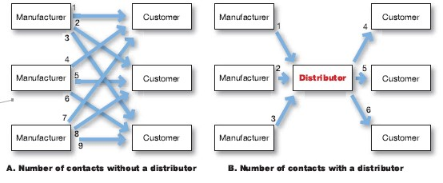

*Source: Kotler and Armstrong (2016)*

In addition to the above, marketing intermediaries transform the assortments of products made by producers into an assortment wanted by consumers. As a result, even though manufactures produce products in larger quantities, consumers can buy products in quantities they want. Thus, with the intervention of marketing intermediaries, major time, place, and possession gaps are removed or minimized. Accordingly, today, consumers can save their time and receive the ownerships of properties, as they can buy the products they want from the nearest retailer or wholesaler they have access.

**Functions Performed by Marketing Channel Members**

###### Key Functions

* **Information:** Gathering and distributing information about consumers, producers, and other actors and forces in the marketing environment needed for planning and aiding exchange.
* **Promotion:** Developing and spreading persuasive communications about an offer.
* **Contact:** Finding and communicating with prospective buyers
* **Matching:** Shaping offers to meet the buyer’s needs, including activities such as manufacturing, grading, assembling, and packaging
* **Negotiation:** Reaching an agreement on price and other terms so that ownership or possession can be transferred

###### Functions Help to Fulfil the Completed Transactions

* **Physical distribution:** Transporting and storing goods
* **Financing:** Acquiring and using funds to cover the cost of the channel work
* **Risk taking:** Assuming the risks of carrying out the channel work

*Given below is a marketing channel of a well*

*-*

*known*

*biscuit*

*manufacturer in Sri Lanka.*



9

.1

*Manufactur*

*Distributor*

*Wholesaler*

*Supermar*

*ket*

*Co*

*nsume*

*Identify and briefly describe the tasks performed by each member of the marketing channel of the biscuit manufacturer*

##### 9.2.2 Number of Channel Levels and Flows

Companies can design their distribution channels to make products and services available to customers in different ways. Also, these different channels consist of different levels.

**Channel Level -** Each layer of marketing intermediaries that performs some work in bringing the product and its ownership closer to the final buyer.

As both the producer and the final consumer perform some work, they are part of every channel. The number of intermediary levels indicates the length of a channel. The figure 9.2 below depicts consumer marketing channels with different lengths.

###### Figure 9.2: Consumer Marketing Channels



**Producer**



**Consumer**



**Producer**



**Producer**



**Channel 1**

**0**

**-**

**Level**



**Channel 2**

**1**

**-**

**Level**



**Channel 3**

**2**

**-**

**Level**



**Consumer**



**Consumer**



**Retailer**



**Retailer**



**Wholesaler**

According to figure 9.2 above, Channel 1 can be introduced as a direct marketing channel (zero level channel), because it has no intermediaries in between producer and consumers. Channel number 2 and 3 are indirect marketing channel (channel 2 has one intermediary level and channel 3 has two intermediary levels) as they consist of one or more intermediary levels. When the number of levels of a channel increases, the producer’s control over the channel will be lower and the channel’s complexity can be higher.



9.2

*Taking pharmaceutical industry and fashion clothing industry as examples, identify the channel levels that the players in each industry can adopt.*

###### Marketing Flows in a Marketing Channel

All the firms in the channel are connected by different types of flows and these flows can make even channels with only one or few levels very complex. Five marketing flows are listed below and depicts in the figure 9.3.

**Physical flow:** Physical products move from producer to consumers through the marketing channel

**Title flow:** Ownership of a product flows from producer to consumer through the channel

**Payment flow:** Payment flow comes from consumers to producers through the channel

**Information flow:** Marketing/ product related information passes from producers to consumers and, information gathered from consumers (grievances, attitudes, etc.) passes to producers through the channel. Further, information can be shared among intermediaries as well.

**Promotion flow:** Marketing communications flow from producers or other intermediaries to consumers

###### Figure 9.3: Five Marketing Flows in a Marketing Channel

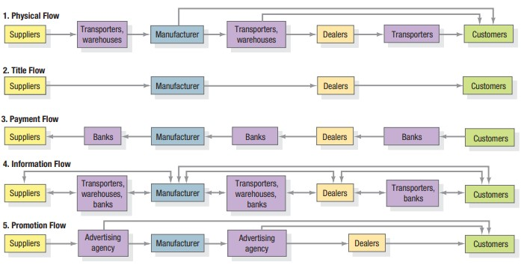

***Source: Kotler and Keller (2012)***

#### 9.3 Channel Behaviour and Organization

Distribution channels are more than simple collections of firms tied together by various flows. They are complex behavioural systems in which people and companies interact to accomplish individual, company, and channel goals. Some channel systems consist of only informal interactions among loosely organized firms. Others consist of formal interactions guided by strong organizational structures. Moreover, channel systems do not stand still – new types of intermediaries emerge and whole new channel systems evolve.

##### 9.3.1 Channel Behaviour

A marketing channel consists of firms that have partnered for their common good. Each channel member depends on the other. Also, each channel member plays a specialized role in the channel.

Ideally, because the success of individual channel members depends on the overall channel’s success, all channel firms should work together smoothly. They should understand and accept their roles, coordinate their activities, and corporate to attain overall channel goals. However, individual channel members rarely take such board view. Individual Channel members has to understand that cooperating to achieve overall channel goals sometimes means giving up individual company goals. Although channel members depend on one another, they often act alone in their own shortrun best interests too. They often disagree on who should do what and for what rewards. Such disagreements over goals, roles, and rewards generate channel conflict.

**Channel Conflicts –** Disagreements among marketing channel members over goals, roles, and

rewards – who should do what and for what rewards.

**Horizontal Channel Conflict:** Occurs among firms at the same level of the channel. There can be some conflicts among different retailers of a particular channel.

**Vertical Channel Conflict:** Conflict between different levels of the same channel. There can be some conflicts between retailer and wholesaler or manufacturer and resellers.

##### 9.3.2 Vertical Marketing System

For a channel to perform well as a whole, each channel member’s role must be specified, and channel conflict must be managed. The channel will perform better if it includes a firm, agency, or mechanism that provides leadership and has the power to assign roles and manage conflict. Historically, conventional distribution channels have lacked such leadership and power, often resulting in demanding conflict and poor performance. However, emergence of vertical marketing systems has provided a solution to this.

**A conventional distribution channel** consists of one or more independent producers, wholesalers, and resellers. Each is a separate business seeking to maximize its own profits, perhaps even at the expense of the system as a whole. No channel members have much control over the other members, and no formal means exists for assigning roles and resolving channel conflict.

In contrast, a **vertical marketing system (VMS)** consists of producers, wholesalers and retailers acting as a unified system. One channel member owns the others, has contracts with them, or has so much power that they all cooperate. The VMS can be dominated by the producer, the wholesaler, or the reseller.

The figure 9.4 below compares a traditional marketing channel with a vertical marketing system.

###### Figure 9.4: Conventional Distribution Channel and Vertical Marketing System



**Vertical Marketing System**



**Producer**



**Wholesaler**



**Retailer**



**Consumer**



**Conventional Marketing Channel**



**Producer**



**Wholesaler**



**Retailer**



**Consumer**

##### 9.3.3 Horizontal Marketing Systems

Horizontal marketing system is a channel arrangement in which two or more companies at one level join to follow a new marketing opportunity. By working together, companies can combine their financial, production, or marketing resources to accomplish more than any one company could alone. Companies might join forces with competitors or noncompetitors. They might work with each other on a temporary or permanent basis, or they may create a separate company.

##### 9.3.4 Multichannel Distribution Systems

In the past, many companies used a single channel to sell to a single market or market segment. Today, with the proliferation of customer segments and channel possibilities, more and more companies have adopted multichannel distribution systems.

**Multichannel Distribution System -** A distribution system in which a single firm sets up two or more marketing channels to reach one or more customer segments.

The figure 9.5 shows a multichannel distribution system.

###### Figure 9.5: Multichannel Distribution System



**Producer**



**Consumer**

**Segment 1**



**Consumer**

**Segment 2**



**Business**

**Segment 1**



**Business**

**Segment 2**



**Retailers**



**Dist**

**ributor**



**Dealers**



**Catalog,**

**Telephone**

**, Internet**



**Sales**

**force**

##### 9.3.5 Changing Channel Organization: Disintermediation

Changes in technology and the growth of direct and online marketing are having a profound impact on the nature and design of marketing channels. One major trend is the disintermediation. Disintermediation is defined as the cutting out of marketing channel intermediaries by product or service producers or the displacement of traditional resellers by radical new types of intermediaries. Thus, in many industries it can be identified that traditional intermediaries are replaced by new and innovative channels. Disintermediation presents both opportunities and problems for producers and resellers.

*Assume that ‘Fendy Shoe’ is a leading shoe manufacturer operating in the Sri Lankan market. Currently ‘Fendy*



9.3

*Shoe’ caters to different customers available in the market.*

1. *Do you think that a company like ‘Fendy Shoe’ can rely on one marketing channel to reach its*

*customers? Explain.*

1. *Identify the possible marketing channels ‘Fendy*

*Shoe’ can use to reach its different customer segments.*

#### 9.4 Channel Design Decisions

In designing marketing channels, there are four key channel design decisions manufacturers need to take.

1. **Analyzing Consumer Needs:** Designing the marketing channel starts with finding out what target consumers want from the channel. Do consumers want to buy from nearby locations?Are they willing to travel to more distant and centralized locations? Would customers rather buy in person, by phone, or online? Etc.

1. **Setting Channel Objectives:** Companies should state their marketing channel objectives in terms of targeted levels of customer service. The company’s channel objectives are also influenced by the nature of the company, its products, its marketing intermediaries, its competitors, and the environment.

1. **Identifying Major Alternatives:** When the company has defined its channel objectives, it should next identify its major channel alternatives in terms of the type of intermediaries (online/ direct marketing/ retailers), the number of intermediaries (intensive/ exclusive/ selective), and the terms and responsibilities (price policies, conditions of sale, territory rights, etc.) of each channel member.

##### Number of Marketing Intermediaries

* **Intensive distribution –** Stocking the product in as many outlets as possible.
* **Exclusive distribution –** Giving a limited number of dealers the exclusive right to distribute the company’s products in their territories.
* **Selective distribution –** The use of more than one but fewer than all of the intermediaries who are willing to carry the company’s products.

**4. Evaluating the Major Alternatives:** When there are several channel alternatives and wants to select a one, each alternative should be evaluated against economic, control, and adaptive criteria.

**Economic criteria –** A company compares the likely sales, costs, and profitability of different channel alternatives.

**Control criteria:** Giving intermediaries some control over the marketing of the product and some controls can be kept with the company.

**Adaptability criteria:** Company wants to keep the channels flexible so that it can adapt to environmental changes.

#### 9.5 Channel Management Decisions

Once the company has reviewed its channel alternatives and determined the best channel design, it must implement and manage the chosen channel. Following activities need to follow when managing marketing channels.

* **Selecting Channel Members:** Producers vary in their ability to attract qualified marketing intermediaries.

* **Managing and Motivating Channel Members:** Once selected, channel members must be continuously managed and motivated to do their best.

* **Evaluating Channel Members:** The company must regularly check channel members’ performance against standards such as sales quotas, average inventory levels, customer delivery time, service to the customer, etc.

Select any manufacturer of your choice and identify different partners in the value delivery network of the selected manufacturer. Then, critically evaluate the marketing channel of your selected manufacturer.



**Think**

**Deep**



Provide your suggestions where appropriate.

# Communicating Customer Value: IMC Strategy

## Chapter Overview

Knowledge of marketing communication is vital for a marketer/manager since, Integrated Marketing Communication is one of the main parts of marketing mix. Further, everyone in the modern world is influenced to some degree by marketing communications and it is known to be a dynamic and fascinating field to study and even at the practice. Hence, marketing communication tools, tactics and strategies have been discussed under the chapter with the intention of understanding and applying it at the individual, business, and society levels.

## Learning Outcomes

At the end of this chapter you should be able to;

* Describe integrated marketing communication and its relevance in marketing management.
* Describe marketing communication tools.
* Describe the process of developing effective marketing communication strategy.
* Examine the effective marketing communication tools for specific contexts given
* Evaluate the effective marketing communication strategy for specific brands.

### 10.1 Communication

Communication is simply exchanging ideas with each other. The modes of communication are by verbal, written, symbolic, gestures or posture. This definition suggests that, for communication to occur there must be some common thinking between two parties and information must be passed from one person to another or from one group to another. It is important to note that the intended target for any basic communication is the receiver. This could be purchasing agents listening to a sales presentation or a consumer reading a magazine advertisement etc.

### 10.2 Marketing Communication

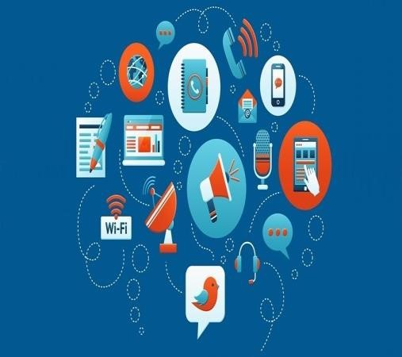Marketing communication has no difference from general communication. Simply it is the exchange of ideas between consumers and the company (brand). Today there is a new view of marketing communications as an interactive dialogue between the company and its customers that takes place during the pre-selling, selling, consuming and post consuming stages. Companies must consider not only how they reach the customer but also how customers reach the companies.

For many organizations marketing communication represents the most visible face of the organization. In deciding how best the communication program is managed is a matter of how it is integrated with the other elements of the marketing mix to achieve the greatest degree of synergy.

### 10.3 The Role of Marketing Communication

As per the marketing definition ‘communicating a value’ is important. Hence, marketing communication has a clear goal to be achieved. There may be intermediate steps on the path to that goal, such as developing favourable consumer attitudes. There are three major objectives of Marketing Communications.

1. to inform,
2. to persuade, and
3. to remind the target audience.

### 10.4 Communication Process

Communication model is used to explain the communication process which includes nine elements. Marketers are required to understand these elements to have an effective communication with its target audience. (Please refer the figure 10.1)

To have effective communication, the sender of the message should know what audiences they want to reach and what responses they want to get. They must encode their messages in a way that is understandable to the target audience who usually decodes messages. They must transmit the message through efficient media that reach the target audiences and develop feedback channels to monitor the responses.

For a message to be effective, the senders’ encoding process must match with the receiver’s decoding process. The more the sender’s field of experience overlaps with that of the receiver, the more effective the message is likely to be. This puts a burden on communicators from one social stratum that wants to communicate effectively with another stratum.

According to the communication model, the sender of a message is trying to deliver a message to a receiver, a potential customer. It is also noted that the customers evaluate not only the message but also the source of the message in terms of trustworthiness and credibility according to many research studies in communication.

#### Figure 10.1: Communication Process

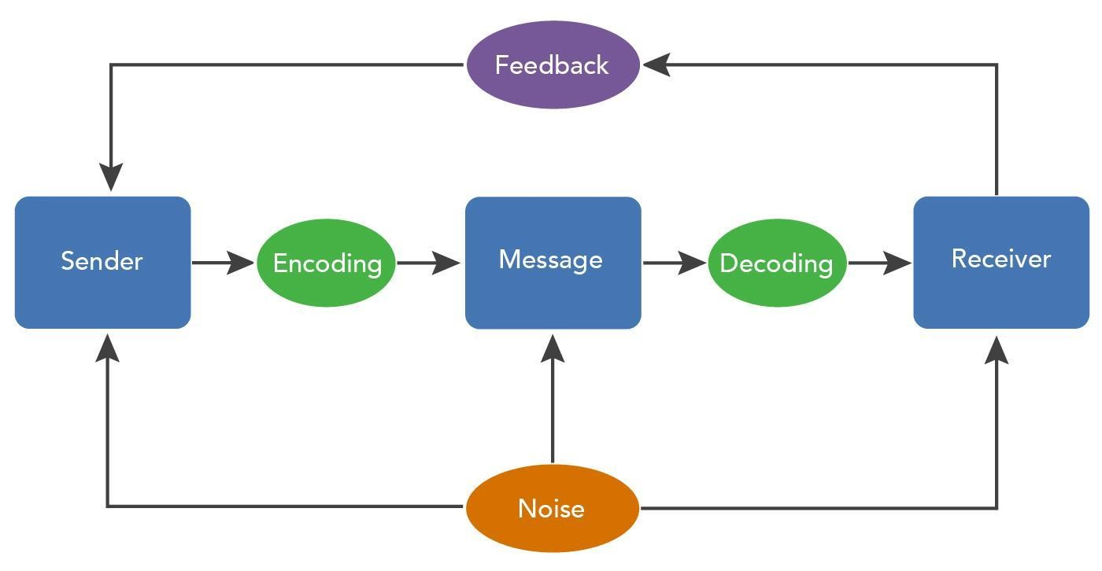

##### 10.4.1 Source (Sender)

The sender or source of a communication is the person or organization that has information to share with another person or group of people. The source may be and individual (salesperson or hired spokesman such as celebrity who appears in a company’s advertisement) or a non-personal entity (such as corporation or organization itself)

The marketer can be considered as the source, or message sender in the marketing communication~~s~~ process. One of the major roles in marketing communication is played by two types of sources: the message sponsor and the message presenter. The message sponsor is typically an organization which attempts to market its goods, services, or ideas. The message presenter, perhaps a salesperson, actor, or television personality who delivers the message. The sender’s task is to get his or her message to the receiver. The target audience may not receive the intended message for any of three reasons, selective attention, selective distortion, and selective retention.

##### 10.4.2 Encoding

Encoding is transferring the message into words or symbols that will have the same meaning to the receiver. The source does the encoding by choosing the words, pictures, and other symbols used to transmit the intended message. The sender’s goal is to encode the message in such a way that it will be understood. In marketing Communication, it is important to encode or prepare the message in such a way it will be understood by the target audience.

##### 10.4.3 Messages

The source sends a message through a channel to a receiver. The marketing communications message represents what the company is trying to convey about its products. A message channel is how the message is conveyed.

##### 10.4.4 Decoding

Decoding is the process by which the receiver translates the message or deciphers the meaning of words, pictures and other symbols used in the message. This is referred to as ‘Frame of Reference’ in marketing communication. When the message is not decoded as the source intended, a distortion of communication results. For example, a consumer may find the copy in a magazine advertisement is too technical and thus not understand the message.

This encoding and decoding process can be very tricky. The meanings of various words and symbols may differ depending on the attitudes and experiences of the two groups. Different audiences may see the same message in different ways or interpret the same words differently. Such differences are common in international marketing when cultural differences or translations are problems. Problems occur even without translation difficulties.

For example, a newly introduced children’s cough syrup was advertised with the theme of “extra strength”. The advertising people wanted to assure the parents with the idea of “speed recovery” from cough. But cautious parents avoided the product because they feared that it might be too strong for their children.

##### 10.4.5 Response (Receiver)

The receiver’s set of reactions after seeing, hearing, or reading the message is known as a response. Response can range from non-observable actions such as storing information in the memory to immediate action such as dialling a toll-free number to order.

##### 10.4.6 Feedback

Feedback is the part of the receiver's response that is communicated to the sender. Depending on the nature of the communication the sender can assess feedback to judge the effectiveness of the communication. Personal selling and many forms of sales promotion offer relatively quick feedback. Feedback is not so immediate for mass advertising and public relations, and only subsequent sales figures or marketing research will indicate the effectiveness of the message. New forms of interactive advertising media are now allowing for quicker feedback from the receiver. As an example, a Facebook post might have immediate response in the way of likes, shares, and comments.

##### 10.4.7 Noise

Noise is any distortion or distraction the communication process that prevents the message from being effectively communicated. Competing messages and interruptions, such as telephone calls during a salesperson’s sales presentation, constitute noise. Noise can even come from within the message itself. Ad clutter is another distortion frequently evident in marketing communication where the audience is bombarded with too many advertisements where they might miss important brand messages.

#### 10.5 Integrated Marketing Communication (IMC)

Why is Coca-Cola continuously in the top list of the most popular and most valuable global brands? Why Sunlight, after hundred and twenty-five years of operation in Sri Lanka, is still not challenged by any other toilet soap brands? Some may argue that it is the traditional advertising which keeps these brands going in the marketplace. Is it true? If advertising is the key factor for a successful brand, how does Dilmah, a brand originated in Sri Lanka, compete in the marketplace without putting a single TV or radio advertisement? How a Lion beer, with the cultural obstacles, prevails in the market without a serious threat? So, the answer is much wider, much broader, and much deeper than the traditional advertising. So, let us have a walk around the magic of Integrated Marketing Communication (IMC), which is the complete answer for all the above questions.

##### 10.5.1 Definitions of IMC

There are number of definitions for IMC.

“Strategic integration of multiple means of communicating with the target market to form a **comprehensive, consistent message”**. *(Marketing principles and Perspectives: William O Bearden,Thomas N Ingram & Raymond w Laforge)*

“**Coordination and integration of all marketing communication tools**, avenues, and sources within a company into a seamless program that maximizes the impact on customer and other stakeholders at a minimal cost”

*“*Delivering a **clear and consistent message** to target audience by integrating all the marketing communication tools available”

An effective **blend of all the firm’s promotion efforts** should produce IMC*. Basic Marketing: A global managerial approach: (William D Perreault, Jr.& E Jerome McFCarthy)*

###### Figure 10.2: Integrated Marketing Communication

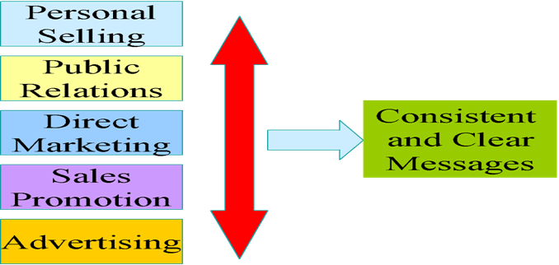

The importance of integrated marketing communication has been documented in a survey of 100 marketing executives. They predicted that integrated marketing communication was the most important factor in shaping marketing strategy in the 1993-98 period, ahead of consumer lifestyles trends, economic trends, everyday low pricing strategies, new retail formats and globalization.

In one sense, Marketing communications are integrated horizontally, or across various methods of communication. For example, the advertising message must be consistent with the personal selling message.

Integration of all the marketing communication tools is paramount important where marketers need to cover all the mediums or paths of communication to deliver the brand message. But marketers must be careful to send a consistent message across all the mediums and to deliver simple message that can be understood by the target audience. Successful communication campaigns which focus on clear and consistent message across all the communication tools are lying behind the world-renowned brands.

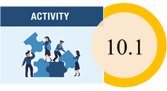 *Discuss the contemporary changes in marketing communication mix with examples.*

#### 10.6 Developing an Effective Communication Strategy

In planning the communications program, the marketing planner needs to take account of eight areas;

* Nature of target audience (s)
* The short term and long-term communication objective(s)
* The messages that are to be used.
* The communication channels that will carry the message
* The budget
* The communication mix tools
* The way in which the elements of the promotions mix are to be integrated and how, in turn, the promotions mix is to be integrated with the marketing mix.
* How the results of the campaign are to be measured.

##### 10.6.1 Deciding upon Target Audience

The process must start with a clear target audience in mind. The starting point in the planning of any communication program involves a detailed statement of the target audience. Without this, it is likely that anything that follows will lack any real focus. The planner therefore needs to think initially about the ways in which the market might possibly be categorized and then how the messages might be or need to be tailored to fit the needs of each of the target groups. Although an audience may be broken up in a variety of ways, the most obvious of these involves a categorization on the basis of whether the target market consists of current or potential users, their needs, their role in the buying process (users, influencers, deciders), their levels of knowledge, their levels of loyalty, and their perceptions on the various products and brands in the market. It is only against this background that decisions can then be taken about what to say, how to say, when to say it, where to say it, and to whom to say it.

 *Can there be differences in ‘target market’ and ‘target audience’? if so, explain two such examples. Explain the importance of recognizing the target audience properly.*

##### 10.6.2 Determining the Communication Objective

Once the target market and its perceptions are identified, the marketing communicator must decide on the desired audience response. The marketer can be seeking a cognitive, affective or behavioral response.

In other words, the marketer may want to put something into the consumer’s mind, change an attitude, or get the consumer to act. There are different models of consumer response stages. All these models assume that the buyer passes through a cognitive, affective and behavioral stage, in that order. The sequence will differ based on the product involvement and differentiation as follows;

Differentiation and Involvement High

Learn

-

feel

-

do

Learn

-

do

-

feel



Do

-

feel

-

learn

Differentiation and Involvement low

Differentiation Low

Involvement High

After the identification of the target audience, the planner’s focus needs then to shift to the question of the communication objectives. These objectives relate to the cognitive, affective, or behavioral responses, which the campaign is designed to achieve. In other words, the planners might be aiming to put something into the consumer’s mind, change the attitude or encourage behaving in a way.

##### Table 10.1: Four Traditional Response Hierarchy Models Which can be Used to Set Communication Objectives

|  |  |  |  |  |
| --- | --- | --- | --- | --- |
|  | **AIDA** | **Hierarchy of Effects Model** | **Innovation Adoption Model** | **Information Processing Model** |
| Cognitive Stage | Attention | Awareness Knowledge | Awareness | Presentation  Attention  Comprehension |
| Affective  Stage | Interest  Desire | Liking  Preference  Conviction | Interest Evaluation | Yielding Retention |
| Behavioural  Stage | Action | Purchase | Trial  Adoption | Behaviour |

###### 10.6.3 Designing the Message

Having defined the desired response, the communicator moves to develop an effective message. Ideally, the message should gain attention, hold interest, arouse desire, and elicit action (AIDA).

Formulating the message will require solving four problems.

1. what to say (message content),
2. how to say it logically (message structure), 3. how to say it symbolically (message format),

4. who would say it (Message source)?

###### 10.6.4 Select the Communication Channels

Communication channels are of two types; personal and non-personal within each are many sub channels

10.6.4.1 Personal Communication Channels

This involves two or more persons communicating directly with each other face to face, person to audience, over the telephone, or through email. Personal communication channels derive their effectiveness through the opportunities for individualizing the presentation and feedback.

There are advocate, expert, and social communication channels. Advocate channels consist of company salespeople contacting Buyers in the target market. Expert channels consist of independent experts making statements to target buyers. Social channels consist of neighbours, friends, family members and associates talking to target buyers. Many marketers are aware of the power of “word of mouth” and are seeking ways to stimulate social channels to recommend products and services.

10.6.4.2 Non-personal Influence Channels

Including the mass media, such as newspapers, television, magazines, the cinema, and posters, which have the advantage, not enjoyed by personnel influence channels, of reaching large numbers of people. However, in doing this, they lack any personal element, with the distinct that the message is more easily ignored and misinterpreted.

###### 10.6.5 Setting the Budget

Although there are various ways in which communication budget might be set, the most common of these are,

* Affordable approach
* Competitive parity
* A percentage of sales
* Objective and task technique

###### 10.6.6 Deciding upon and Integrating the Elements of the Promotions Mix

In deciding which elements to be used, the marketing planner needs to take account of eight steps

* The degree of control that is needed in terms of how the message is delivered.
* The financial resources that are available
* The credibility of each tool in the eyes of the buyer
* The size of target markets and their geographic spread
* The nature of the product and market
* Whether the push or a pull strategy is being used
* The stage reached by the product in its life cycle.
* The buyer’s readiness stage

Against this background, the planner needs then to focus upon the ways in which the various communication tools might be brought together in the form of integrated marketing communication program.

###### 10.6.7 Measuring the Results

This can be done using two dimensions, qualitative measures, and quantitative measures. In the qualitative measures, the planner concerns with attitudinal changes, quantitative measures relate to changes in sales levels, levels of satisfaction, and trial levels. The extent to which a campaign is successful is, however, influenced by a series of factors, many of which outside the control of the marketing planner.

**10.7 Elements that Contributes to Effective Marketing Communication**

#### (Marketing Communication Mix)

##### 10.7.1 Advertising

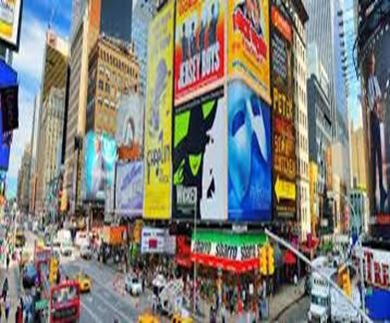Any paid form of nonpersonal presentation and promotion of ideas, goods, or services by an identified sponsor. The paid aspect of this definition reflects the fact that the space or time for an advertising message generally must be bought. The non-personal component means that advertising involves mass media (e.g., TV, radio, magazines, newspapers) that can transmit a message to large groups of individuals, often at the same time.

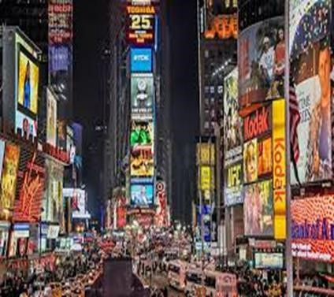 The non-personal nature of advertising means that there is generally no opportunity for immediate feedback from the message recipient (except in direct-response advertising). There are two types of advertising according to Sri Lankan advertising industry classifications. They are “Above the line advertising” (ATL) which is traditional forms of advertising like television, radio, and newspapers and “below the line advertising” (BTL), which is material-based messages like banners, posters, hoardings.

##### 10.7.2 Sales Promotion

“A direct inducement that offers an extra value or incentive for the product, the sales force, distributors, or ultimate consumer with the primary objective of creating an immediate sale.”

Consumer promotions are part of a pull strategy. They work along with advertising to encourage consumers to purchase a brand and thus create a demand for it. Consumer promotions are also used by retailers to encourage consumers to shop in their stores. On the other hand, Trade oriented sales promotion includes dealer contests and incentives, trade allowances, point of purchase displays, sales training programs, trade shows and other programs to motivate distributors and retailers to carry a product and make an extra effort to push it to their customers. These tradeoriented promotions are called push promotion strategies.

###### 10.7.2.1 Types of Sales Promotion Activities

|  |  |
| --- | --- |
| **Consumer Promotions** | **Trade Promotion** |
| Samples  Coupons  Premiums  Contests  Refunds/ rebates | Contests and dealer incentives  Trade allowances  Point of purchase displays  Training programs  Trade shows |

Bonus packs

Price-offs

Frequency programs

##### Types of Sales Promotion Activities

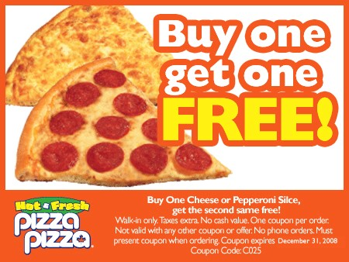

###### 10.7.3 Public relations and Publicity

The traditional explanation of Public Relations (PR) is;

“The management function which evaluates public attitudes, identifies the policies and procedures of an organization with the public interest, and executes a program of action to earn public understanding and acceptance.

**10.7.3.1 Marketing Public Relations (MPR) Functions.**

* Building marketplace excitement before the advertising breaks
* Creating advertising news where there is no product news
* Introducing a product with little or no advertising
* Providing a value-added customer service
* Building brand to customer bonds
* Influencing the influential
* Defending product at risk and giving consumers a reason to buy

10.7.3.2 Publicity

Refers to the generation of news about a person, product or service that appears in broadcast or print media. For many marketers, publicity and public relations are synonymous. In fact, publicity is really a subset of the public relations effort.



###### 10.7.4 Personal selling

Personal selling is a personal presentation by the firm’s sales force for the purpose of making sales and building customer relationships. It is a form of person-to-person communication in which a seller attempts to assist and/or persuade prospective buyers to purchase the company’s product or service or to act on an idea. Unlike advertising, personal selling involves direct contact between buyer and seller, either face-to-face or through some form of telecommunications such as telephone sales.

###### 10.7.5 Direct Marketing

Peter Bennett (Dictionary in marketing terms) defines direct marketing as;

“The total of activities by which the seller, in affecting the exchange of goods and services with the buyer, directs efforts to a target audience using one or more media (direct selling, direct mail, telemarketing, direct action advertising, catalogue selling etc) for the purpose of soliciting a response by phone, mail or personal visit from a prospect or customer.”

Direct marketing activities are implemented through Direct mail, Catalogs, Broadcast media, Infomercials, TV advertorials, Tele shopping, Print media, Electronic Tele shopping and Direct selling.

###### 10.7.6 Interactive Marketing

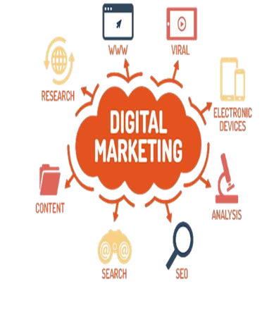Online activities and programs designed to engage customers or prospects and directly or indirectly raise awareness, improve image, or elicit sales of products and services. Interactive media allow for a back-and-forth flow of information whereby users can participate in and modify the form and content of the information they receive in real time. Unlike traditional forms of marketing communications such as advertising, which are oneway in nature, the new media allow users to perform a variety of functions such as receive and alter information and images, make inquiries, respond to questions, and, of course, make purchases.

###### 10.7.7 Events & Experiences

Company-sponsored activities and programs designed to create daily or special brand-related interactions. These events will carry the intended brand personality to target the audience and make the audience engaged with the brand. Red-Bull is one of the famous examples which uses this strategy to communicate with its target audience. They frequently engage with the general public around the country by allowing the people to experience the energy of Red-Bull. They believe that

“engagements” will increase the relationship with customers as well as carry the brand messages that they want to deliver.



###### 10.7.8 Event Sponsorships

Sponsorship is a financial support given by an organization, person, or activity in exchange for the brand publicity and associations. Cause and mission marketing are important types of sponsorships that marry philanthropy with marketing. In a cause related marketing program, a brand promises to donate money or other types of support to an organization or social activity when a customer buys or uses the brand.

*Think about a brand you have come across. What are the different communication tools that the brand has used? Are they conveying a clear and consistent message for the audience? Discuss.*



10.3

###### 10.7.9 Word of Mouth Communications

WOM is People-to-people, oral, written, or electronic communications that relate to the merits or experiences of purchasing or using products or services. There are industries like wedding decorations, photography and bridal dressing which solely focus on WOM as their main strategy in communication. This has been developed up to Buzz marketing campaigns where marketers create public chat about a brand using brand advocates. (Normal people who endorse the brand)

###### 10.10.10 Non-traditional Communications (Covert Marketing)

The goal of non-traditional communications is to identify new places where a consumer’s path intersects with the brand presence. Marketers are focused on brand engagement where they want consumers to engage with the brand before they start consumption. Thus, the importance of nontraditional (covert) communication is ever increasing. Non-traditional communications assist to convey messages through alternative venues which target consumers are waiting for a while.

Video game advertising

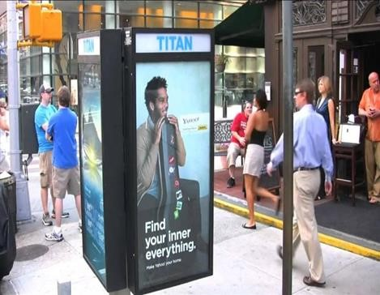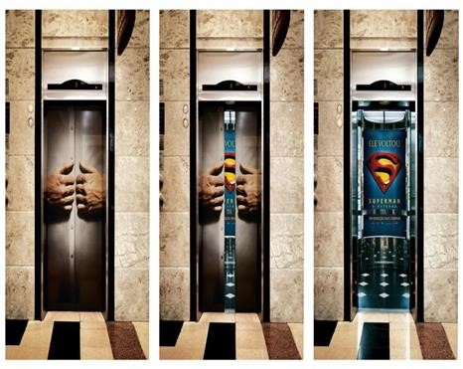

In-tunnel subway advertising

Escalator advertising

Leaflets and brochures

Carry-home bag advertising

Mall signs

Ads by fax

Cinema advertising

Parking lot advertising

Airline in-flight advertising

Carry-home menus

Advertising on clothes

Kiosk ads

Assume that you are hired as a communication manager for a brand of digital screen which is newly launched into the market. Digital Screens are the newest alternative for traditional television which is getting popular among the general public. Digital screens market is fully composed of competitors which offer so many differentiations to highlight their brands. What would be your communication objective at this stage of the product? Justify your answer using one of the response hierarchy models.



***Think***

***Deep***

**10.1**



Do you think television advertising in Sri Lanka is effective for all the brands? What are the product categories that television advertising is effective?



***Think***

***Deep***

**10.2**



Justify your answer.